TAYABASCARE: PRESCRIPTIVE ESTABLISHMENT VIOLATIONS USING HISTORICAL INSPECTION DATA FOR CITY HEALTH OFFICE OF TAYABAS CITY

A Thesis
Presented to the Faculty of the
Information and Communications Technology Program
STI College Lucena

In Partial Fulfilment
of the Requirements for the Degree
Bachelor of Science in Computer Science
Aeron James P. Fontanilla
Charlie J. Mercado
Kurt Jerven S. Panaligan
Christian Nemesius C. Reyes

November 2026

ENDORSEMENT FORM FOR ORAL DEFENSE

TITLE OF RESEARCH: TayabasCare: Prescriptive Establishment
Violations Using Historical Inspection Data
for City Health Office of Tayabas City

NAME OF PROPONENTS: Aeron James. P Fontanilla
Charlie J. Mercado
Kurt Jerven S. Panaligan
Christian Nemesius C. Reyes

In Partial Fulfilment of the Requirements
for the degree Bachelor of Science in Computer Science
has been examined and is recommended for Oral Defense.

ENDORSED BY:

Aldrin P. Catubay
Thesis Adviser

APPROVED FOR ORAL DEFENSE:

Gemiloi B. Ella
Thesis Coordinator

NOTED BY:

Engr.Ronald Florrenz A. Dela Cruz
Program Head

November 2026

APPROVAL SHEET
This thesis titled TayabasCare: Prescriptive Establishment Violations Using Historical Inspection Data for City Health Office of Tayabas City, prepared and submitted by Aeron James P. Fontanilla, Charlie J. Mercado, Kurt Jerven S. Panaligan, and Christian Nemesius C. Reyes in partial fulfillment of the requirements for the degree of Bachelor of Science in Computer Science, has been examined and is recommended for acceptance and approval.

Aldrin P. Catubay
Thesis Adviser

Accepted and approved by the Thesis Review Panel
in partial fulfillment of the requirements for the degree of Bachelor of Science in Computer Science

Rico Hachaso | Gemiloi B Ella
Panel Member | Panel Member

Catherine Valenzuela Cornejo
Lead Panelist

Noted:

Gemiloi B Ella | Engr. Ronald Florrenz A. Dela Cruz
Thesis Coordinator | Program Head

November 2026
ACKNOWLEDGEMENT

Thesis Coordinator, Ms Gemiloi B Ella, for her unwavering guidance, support, and encouragement throughout the development of this study, for providing valuable insights and direction that helped shape the research entitled "TayabasCare: Prescriptive Establishment Violations Using Historical Inspection Data for City Health Office of Tayabas City", and for ensuring that the study met academic standards.

Thesis adviser, Mr. Aldrin P. Catubay, for his continuous support, patience, and expertise in guiding the researchers from conceptualization to system development, for sharing his technical knowledge in web-based systems and for providing constructive feedback that greatly improved the quality of the system and the manuscript.

Parents and/or Guardian, for their unconditional love, moral and financial support, understanding, and endless encouragement which served as the researchers' strength and inspiration to persevere and complete this study despite all challenges;

Friends and inspirations, for their companionship, motivation, and help during the brainstorming, development, and documentation phases of the system, for sharing ideas and for making the thesis journey more bearable and meaningful; and

Others, to Sir Rommel D. Sate and Sir Zaldy A. Ramos of the City Health Office of Tayabas City, for their cooperation and for providing the necessary data and information regarding sanitation inspection processes, to STI College Lucena for providing the resources and learning environment, and to Almighty God for His wisdom, guidance, and blessings that made the successful completion of this research possible.

ABSTRACT

Title of research: TAYABASCARE: PRESCRIPTIVE ESTABLISHMENT VIOLATIONS USING HISTORICAL INSPECTION DATA FOR CITY HEALTH OFFICE OF TAYABAS CITY
Researchers: Aeron James P. Fontanilla,
Charlie J. Mercado,
Kurt Jerven S. Panaligan,
Christian Nemesius C. Reyes

Degree: Bachelor of Science in Computer Science
Date of Completion: November 2026

Keywords:TayabasCare, Prescriptive Analytics, Sanitation Inspection, Risk Scoring, Web-based System, City Health Office, Historical Data
The City Health Office of Tayabas City is responsible for monitoring around 3,000 business establishments, yet it still relies on paper-based, manual methods for sanitation inspection and reporting. Because the Department of Health requires monthly, quarterly, and yearly reports, inspectors end up encoding the same establishment data at least three times. This repetition slows the work down, invites typing mistakes, leaves records inconsistent, and delays the release of reports.

This study designed and developed TayabasCare, a web-based prescriptive system that utilized historical inspection data to flag potential violations. Historical records were gathered, digitized, and consolidated into a centralized database. The data were analyzed to identify violation patterns and establish risk criteria based on establishment type, frequency of violations, compliance history, and PD 856.
The system was implemented as a web-based platform comprising five integrated modules, User Management Module for role-based access and authentication, Sanitary Records Module for maintaining the inventory of establishments, Inspection Report Module for systematic documentation of compliance, Reporting Module for automated generation of reports, and Dashboard Module for real-time visualization of metrics. It incorporated automated risk assessment that classified establishments into low, moderate, and high-risk categories, notification features for inspection scheduling, data validation, and audit trails.
With single-entry encoding, inspectors no longer have to retype the same data, and reports are produced automatically. The dashboards turn raw inspection records into information the office can act on. Altogether, TayabasCare helps the City Health Office work faster, keep its data accurate and traceable, focus on high-risk establishments first, and base its decisions and enforcement on evidence.

TABLE OF CONTENTS
 |  | Page
Title Page |  | i
Endorsement Form for Oral Defense |  | ii
Approval Sheet |  | iii
Acknowledgement |  | iv
Abstract |  | v
Table of Contents |  | vi
Introduction |  | 9
 | Background of the problem | 10
 | Overview of the current state of technology | 12
 | Objectives of the study | 13
 | Scope and limitations of the study  Review of related literature/studies/systems | 16  30
Methodology |  | 37
Results and Discussions |  | 40
Conclusion |  | 51
 | Hardware/Software | 53
 | Calendar of Activities | 60
 | Budgetary Estimate | 67
 | Human Resources | 68
References |  | 75
Appendices |  | 77

LIST OF TABLES

 | Page
Table 1. Data encoding before and after the system | 41
Table 2. Summary of digitized records | 41
Table 3. Sample of digitized raw data | 42
Table 4. Violations by establishment category | 43
Table 5. Establishments and violations by barangay | 43
Table 6. Most common violation types | 43
Table 7. Risk scoring criteria | 44
Table 8. Risk level classification | 44
Table 9. Implementation of the five system modules | 45
Table 10. Security and access control features | 45
Table 11. Unit, integration and system test results | 46
Table 12. Stress test results | 46
Table 13. Risk level distribution of establishments | 47
Table 14. Highest-risk establishments with score breakdown | 47
Table 15. Inspection interval by risk level | 47
Table 16. Prescribed actions | 47
Table 17. Sample system-generated risk narrative | 48
Table 18. Automated alert and notification rules | 48
Table 19. Sample notification log | 48
Table 20. Dashboard components | 49
Table 21. Report and export functions | 49
Table 22. Gantt chart calendar of activities | 65
Table 23. Gantt chart calendar of activities | 66

LIST OF FIGURES
 | Page
Figure 1. User module | 18
Figure 2. Sanitary records module | 19
Figure 3. Inspection report module | 20
Figure 4. Inspection history module | 20
Figure 5. Reports module | 21
Figure 6. Accomplishment module | 22
Figure 7. Dashboard module | 23
Figure 8. Burial records module | 24
Figure 9. Schedule module | 25
Figure 10. Prescription module | 26
Figure 11. Activity log module | 27
Figure 12. Archive module | 27
Figure 13. Agile methodology framework diagram | 37
Figure 14. Lenovo laptop | 53
Figure 15. Asus laptop | 54
Figure 16. HP laptop | 55
Figure 17. Redmi Note 12 smartphone | 56
Figure 18. Microsoft Word v.2404 | 57
Figure 19. Figma | 57
Figure 20. Canva | 57
Figure 21. Google Drive | 58
Figure 22. XAMPP v.3.3.0 | 58
Figure 23. MySQL | 58
Figure 24. Visual Studio Code v.1.105.1 | 59
Figure 25. Proposal Gantt chart of activities | 65
Figure 26. Proposal Gantt chart of activities | 66
Figure 27. Entity relationship diagram | 123

LIST OF APPENDICES
 | Page
- Letter and Transcript of Interviews | 82
- Consultation Papers | 116
- Entity Relationship Diagram | 123

INTRODUCTION
The advancement of information technology has revolutionized how organizations manage data and streamline operational processes across various sectors, and web-based systems have become essential tools for improving efficiency, accuracy, and accessibility in data collection and reporting activities (Pressman & Maxim, 2024). In the context of public health administration, digital platforms designed for sanitation and environmental health monitoring have enabled local government units to maintain comprehensive records, generate timely reports, and ensure compliance with regulatory standards (World Health Organization, 2021). TayabasCare is a prescriptive system for establishment violations built on historical inspection data, developed for the City Health Office of Tayabas City. It modernizes the documentation and monitoring of sanitation inspections of establishments within the city's jurisdiction by storing inspection records in a centralized database where they can be retrieved, reported, and analyzed to support evidence-based decision-making. Beyond record-keeping, TayabasCare applies prescriptive analytics to the historical inspection data to identify establishments with recurring or likely sanitation violations and to recommend the inspection priority and corrective action for each.
Despite the proven benefits of digital health information systems (Smith-Mitchell, 2025), many municipalities in the Philippines continued to rely on traditional paper-based and manual methods for managing sanitation environmental health data. The City Health Office of Tayabas City operated without an integrated digital system for sanitation data management, which required health inspectors to manually document establishment information and inspection results using paper forms and spreadsheets (R. D. Sate, personal communication, November 21, 2025). This lack of technological infrastructure created significant barriers to efficient data management, particularly as the volume of establishments requiring regular monitoring continued to grow. Without a centralized database system, the retrieval of historical inspection records, trend analysis, and cross-referencing of establishment data became labor-intensive tasks that diverted valuable time and resources from actual field inspections and public health interventions (Alharbi, 2025). The absence of automated reporting capabilities further compounded these challenges, forcing staff members to manually compile data from multiple sources whenever reports were required by higher authorities or for internal analysis (Byrne and Heywood, 2023).
TayabasCare responds to these gaps through a single-entry, web-based database that records establishment and inspection data once and then generates the monthly, quarterly, and yearly reports the City Health Office is required to submit (Byrne and Heywood, 2023; World Health Organization, 2021). This chapter presents the background of the problem, the current state of the technology, the objectives of the study, and the scope and limitations of the study that guided the design and development of the system.

Background of the problem
According to Sir Rommel D. Sate (personal communication, November 21, 2025), the City Health Office of Tayabas City managed sanitation environmental health data collection and reporting for approximately 3,000 establishments across the city using a manual, paper-based system that required sanitation inspectors to physically document inspection results and manually compile reports for various time periods. These methods often caused data redundancy, inconsistencies, and delays in report generation when staff members had to repeatedly encode the same information. While national health offices and other progressive local government units had successfully transitioned to digital health information systems, the City Health Office of Tayabas City continued to rely on manual procedures that constrained operational efficiency and data accuracy (Ali et al., 2023).
In the public health environment, efficiency and data accuracy mattered significantly, as sanitation inspectors and health administrators required timely access to establishment records for monitoring compliance and generating mandatory reports to the Department of Health. However, manual record-keeping made it difficult for health officers to keep up: it consumed excessive time, increased data entry errors, and complicated historical trend analysis. According to documented research, local government health offices using manual data management systems experienced operational delays, document misplacement, and difficulty in data-driven decision-making regarding sanitation compliance and public health interventions (Ali et al., 2023; World Health Organization, 2021).
In the case of the City Health Office of Tayabas City, sanitation inspectors constantly used physical forms and spreadsheets to record establishment data from initial inspection through report generation, a process that proved prone to inefficiencies and created substantial room for operational errors. In an interview, Sir Rommel D. Sate (Sanitation Inspector V) reported that establishment data had to be encoded at least three separate times to generate the monthly and quarterly reports. He explained that the same establishment information was repeatedly entered across different reporting periods, indicating that redundant data entry consumed inspection staff time that could have been allocated to conducting actual field inspections and promoting sanitation compliance across the establishments under their jurisdiction.
Sir Rommel D. Sate identified data redundancy as the primary operational challenge: the office collected sanitation data from establishments on a monthly, quarterly, and yearly basis, but the absence of an integrated database system forced inspectors to encode the same information multiple times for each reporting period. Given the large volume of establishments requiring regular monitoring, this repetitive process not only wasted valuable staff time but also increased the likelihood of data entry errors and inconsistencies across different reports, potentially compromising the reliability of public health surveillance data. Research demonstrated that redundant data entry in manual health information systems significantly increased the probability of transcription errors and data quality issues, particularly when dealing with large datasets (Byrne and Heywood, 2023).
Because of these documented operational challenges, sanitation inspectors experienced excessive workload from redundant data entry, health administrators faced delays in report generation that could affect compliance with Department of Health deadlines, and the lack of centralized data storage made it difficult to retrieve historical inspection records for trend analysis and decision-making purposes (Smith-Mitchell, 2025). The absence of automated report generation capabilities forced staff members to manually compile data from multiple sources whenever reports were required, wasting time that could have been dedicated to proactive sanitation monitoring and establishment compliance support in Tayabas City (Byrne and Heywood, 2023). Furthermore, the manual nature of the system made data validation and quality control challenging, increasing the risk of inaccurate information being submitted in official reports (World Health Organization, 2021).
A comprehensive web-based sanitation environmental health data collection and reporting system addressed these operational deficiencies by implementing a single-entry database architecture, automating report generation for multiple time periods, providing centralized data storage with easy retrieval capabilities, and enabling real-time data access for authorized users, thereby enhancing operational efficiency while ensuring data accuracy and supporting evidence-based public health decision-making in Tayabas City (Pressman & Maxim, 2024).

Overview of the current state of the technology
In recent years, web-based technologies have transformed how organizations monitor, document, and manage information across different sectors. These online systems offer tools for real-time data entry, centralized databases, automated validation, and analytics dashboards, enabling institutions to streamline their operations while enhancing accuracy and transparency.
However, despite the availability of these advanced digital solutions, many local government units in the Philippines, including Tayabas City, still rely heavily on traditional, paper-based methods when inspecting or monitoring establishments. Manual logging, physical record storage, and handwritten reports often result in inconsistencies, misplaced files, delayed submissions, and difficulty in generating consolidated reports. Establishments must repeatedly submit documents, while city personnel spend a significant amount of time compiling and validating paper forms.
The introduction of a modern web-based system for establishment monitoring in Tayabas City offers a significant opportunity to shift away from outdated manual processes. By adopting a centralized digital platform, the city can enhance the efficiency of inspections, improve record accessibility, reduce redundancy, and ensure timely reporting. This transition aligns Tayabas City’s regulatory processes with current technological standards and supports a more systematic approach to managing establishment-related data.

Objectives of the study
The overarching objective of this study was to design, develop, and evaluate TayabasCare, a prescriptive and data-driven inspection support system that utilizes historical inspection records to identify and flag possible sanitary violations among business establishments within Tayabas City. The study aimed to transform the traditional, manual, and often inconsistent inspection workflow of the City Health Office into a more efficient, proactive, and evidence-based process. Through the integration of prescriptive analytics, rule-based risk scoring, digital reporting, and interactive data visualization, the study sought not only to modernize local health compliance monitoring but also to strengthen public health safety and regulatory enforcement in the city. More specifically, the study intends to accomplish the following detailed objectives:
- The study gathered, consolidated, and digitized historical inspection data from the City Health Office of Tayabas City into a structured database.
The system collected inspection records including establishment information, violation history, inspection dates, and compliance status from the City Health Office's existing records. By organizing scattered paper-based or manually-kept records into a centralized digital database, the system created a standardized repository where all establishment profiles, past violations, and inspection histories were stored systematically. This digitization replaced manual filing systems with an organized digital archive that allows quick retrieval of establishment information and provides the foundation for analyzing violation patterns across different establishment types and time periods.
- The study analyzed historical inspection data to identify violation patterns and established risk scoring criteria based on establishment characteristics and compliance history.
The system examined digitized inspection records to identify patterns such as which types of establishments frequently violate regulations, which violations occur most commonly, and whether certain establishment characteristics correlate with higher non-compliance rates. Through statistical analysis of violation frequency, recurrence rates, and establishment attributes, the system established risk scoring criteria using measurable factors such as: number of previous violations, time since last violation, establishment category, compliance history percentage, and follow-up action completion rates. This analysis provides the basis for creating a transparent and auditable rule-based risk scoring formula that categorizes establishments based on measurable compliance indicators grounded in PD 856.
- TayabasCare was designed and implemented as a web-based platform that manages inspection records, calculates risk scores, and supports inspection scheduling and documentation.
The system provided a centralized web interface where health inspectors and administrators could access establishment profiles, record new inspection results using digital forms, view automatically calculated risk scores based on the established scoring criteria, and schedule upcoming inspections prioritized by risk levels. The platform included modules for encoding inspection findings through structured checklists, uploading supporting documents or photos, generating inspection reports, and maintaining complete audit trails of all activities. Role-based access controls ensure inspectors can perform field data entry while administrators have additional privileges for managing users, reviewing analytics, and adjusting system parameters. This web-based implementation eliminates paper-based workflows, centralizes fragmented records, and provides the City Health Office with organized digital tools for managing their inspection operations.
- Automated risk assessment and notification features that prioritize high-risk establishments and alert personnel about inspection schedules and compliance issues.
The system automatically calculated risk scores for each establishment using the predefined scoring formula based on factors like violation history, establishment type, and compliance trends, then classified establishments into risk categories (low, moderate, high) to help inspectors prioritize their workload. Automated notifications alerted inspectors when inspections are due based on risk levels—high-risk establishments receive more frequent inspection schedules while low-risk establishments have longer intervals between visits. The system sends email reminders to inspectors about upcoming scheduled inspections, alerts administrators when establishments accumulate violations exceeding threshold limits, and notifies relevant personnel when follow-up actions remain incomplete past deadline dates. This automated prioritization ensures limited inspection resources focus on establishments most likely to present compliance concerns based on their documented history.
- Analytical dashboards and reporting features that visualize violation trends, compliance statistics, and establishment risk distributions for informed decision-making.
The system generated visual analytics through dashboards displaying key metrics such as total inspections conducted per month, violation rates by establishment category, distribution of risk levels across all registered establishments, most common violation types, and compliance improvement trends over time. Interactive charts and graphs allowed administrators to filter data by date ranges, establishment types, geographic areas, or specific violation categories to gain insights into sanitation patterns across Tayabas City. The reporting module produces exportable summaries in PDF or Excel formats suitable for presentation to City Health Office leadership or inclusion in official reports, showing statistical breakdowns of inspection activities, establishment compliance performance rankings, and inspector productivity metrics. These analytical tools transform raw inspection data into actionable insights that help administrators identify which establishment categories require targeted interventions, which areas of the city have higher concentration of violations, and whether overall compliance is improving or declining over time, supporting evidence-based policy decisions and strategic resource allocation without relying solely on manual observations or anecdotal assessments.

Scope and limitations of the study

Scope of the study
The system allowed authorized users to securely log in with passwords to protect their accounts. It enables users to save draft reports, view submission history, and review the recorded violation history of each establishment. The system has role-based access for administrators and sanitary inspectors, and it restricts every page and action according to the signed-in user's role.
- Secure Login and User Authentication
The system ensured users are properly identified and verified before accessing system features. It includes individual user account creation with unique usernames, secure activation processes, and session management that logs users out after inactivity. This protects sensitive establishment and inspection data from unauthorized access.
- Password Protection
The system enforced a minimum password length for account credentials, and passwords are stored as salted bcrypt hashes instead of plain text, which protects accounts if the database is ever exposed. Signed-in users are also logged out automatically after a period of inactivity, which limits access to an account left open on an unattended workstation.
- Draft Saving and Report Continuity
Users can save an incomplete inspection report and continue data entry at their convenience without losing what has already been entered. The report form saves a draft automatically in the browser while it is being filled in and offers the draft back when the form is reopened, so an accidental refresh or a lost session does not discard the entry. Drafts are held in the local browser storage of the device until the report is submitted, and they are not synchronised across devices.
- Submission History and Audit Trail
The system maintained a comprehensive archive of all submitted reports with timestamps and submitter information. Users can view previously submitted reports, compare current conditions with historical data, and track compliance progress over time. This creates transparency and provides evidence for enforcement proceedings when necessary.
- Violation Documentation and Data Collection
The system collected inspection findings through a violation checklist that is loaded according to the establishment type being inspected. The checklist draws on the system's violation categories, which are grounded in Presidential Decree No. 856, and covers sanitation conditions such as cleanliness, waste disposal, water supply, and toilet and handwashing facilities as these are recorded by the inspector. Inspectors can also type findings that are not on the list and can upload photos and supporting documents to verify the conditions observed.
- System Modules
The system was organized into the modules used by the City Health Office application. The administrator interface provides Dashboard, Inspector Accounts, Sanitary Records, Burial Records, Inspection Reports, Inspection History, Accomplishment Report, Schedule, Prescription (risk prediction), Activity Log, and Archive. The inspector field interface provides Sanitary Records, Inspection Report, Inspection History, Burial Records, Accomplishment, Reports, and Schedule. The subsections below describe each module and its principal features; figures are provided for the five core modules most often used during inspection work.

- Module 1: Inspector Accounts Module (User Management)
This module provided account administration for City Health Office personnel (admin side: Inspector Accounts). Its features include creating and editing inspector accounts, assigning roles, enabling or disabling status, resetting an inspector password, and listing all registered users. Roles are limited to administrator and inspector: the administrator manages accounts and citywide data, while each inspector signs in with a unique username and a salted bcrypt password, the session ends after inactivity, and the Activity Log records sign-ins and changes.
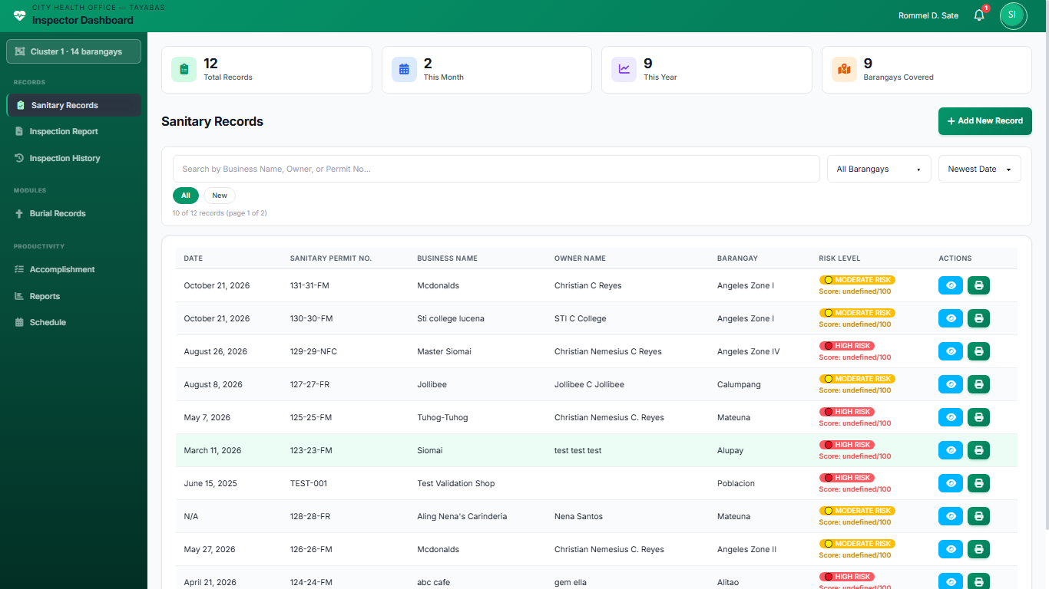
Figure 1. User module.
- Module 2: Sanitary Records Module
This module maintained the institutional inventory of establishments within Tayabas City (both admin and inspector sides). Its features include adding, editing, and archiving establishment records; search and filter by name, barangay, or category; numbered pagination for large lists; bulk import from CSV or Excel; and printing a sanitary permit from the stored profile. Each record holds the business name, address, barangay, establishment category, and contact details so staff share one registry instead of separate paper files. The module is intended to hold the approximately 3,000 registered establishments that require sanitation monitoring.
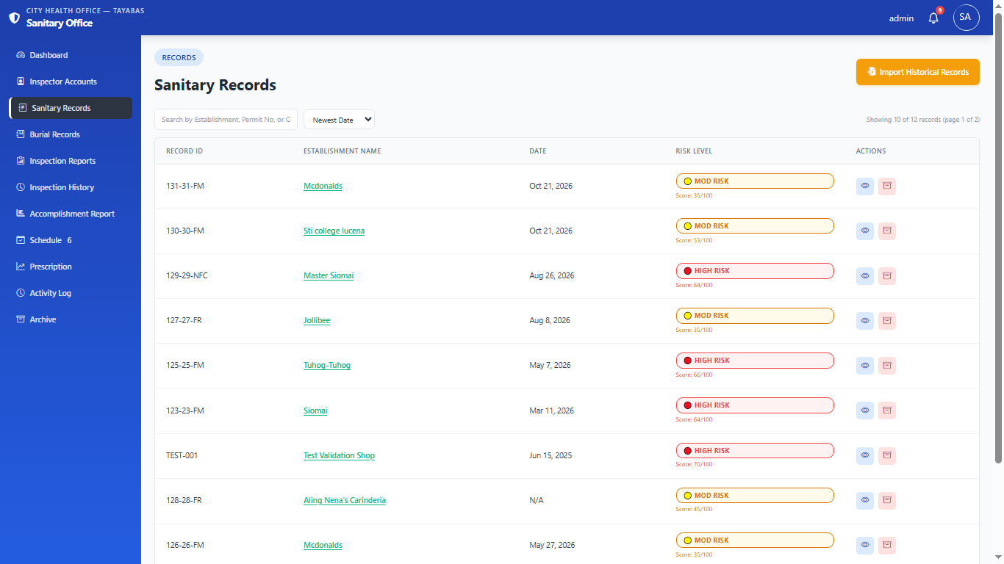
Figure 2. Sanitary records module.

- Module 3: Inspection Report and Inspection History Modules
The Inspection Report module coordinated field inspections. Its features include opening a new inspection from the registry or a cluster-scoped list, completing a structured form with compliance status and a category-based violation checklist, adding free-text findings, uploading photo evidence, saving browser drafts until submission, and submitting the report with timestamp and inspector name. The Inspection History module then shows submitted reports and prior versions so inspectors can compare current conditions with previous visits. Each completed inspection feeds the risk engine, and inspectors only see barangays in their assigned cluster (five clusters covering the 66 barangays).
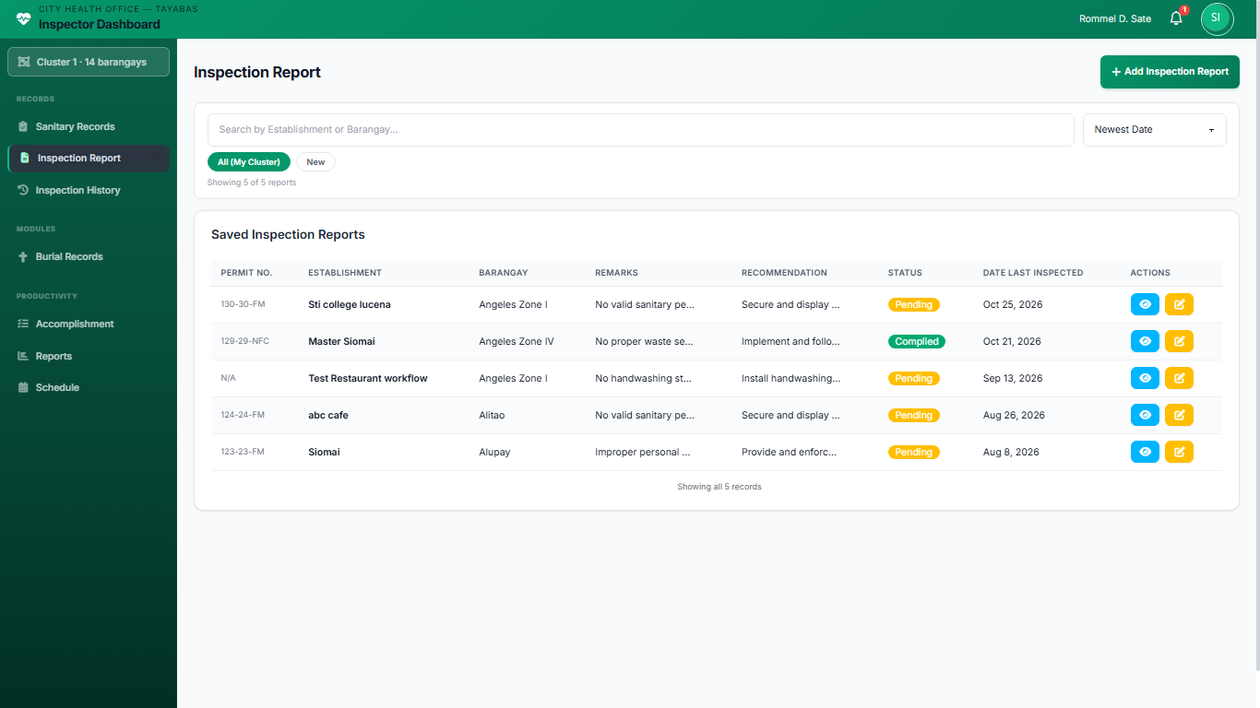
Figure 3. Inspection report module.
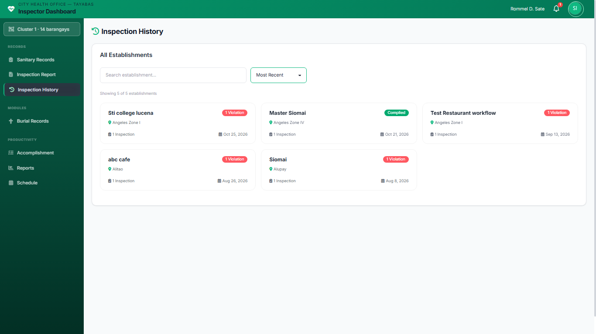
Figure 4. Inspection history module.

- Module 4: Reports and Accomplishment Modules
The Reports module compiled quantitative performance indicators and produced outputs that helped the City Health Office assess compliance and plan interventions without re-encoding the same data. Its features include violation summaries by establishment category and barangay, risk-level distributions, inspection interval and prescribed-action tables, and export to PDF, Excel, or CSV. The Accomplishment module (admin: Accomplishment Report) maintains monthly accomplishment records per inspector; on the inspector side, health-card and burial activities for the selected month are filled automatically from finished records while earlier fields remain manual. All figures come from the same stored records the inspectors already entered.
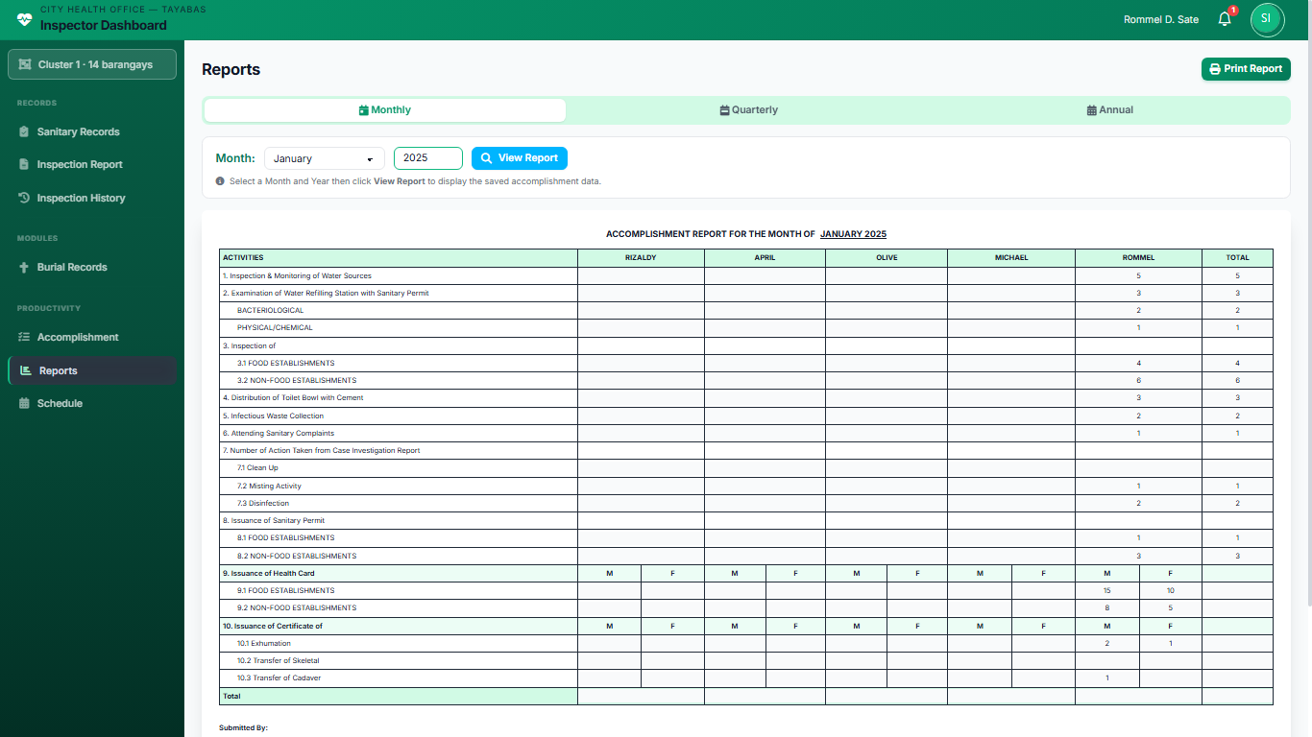Figure 5. Reports module.
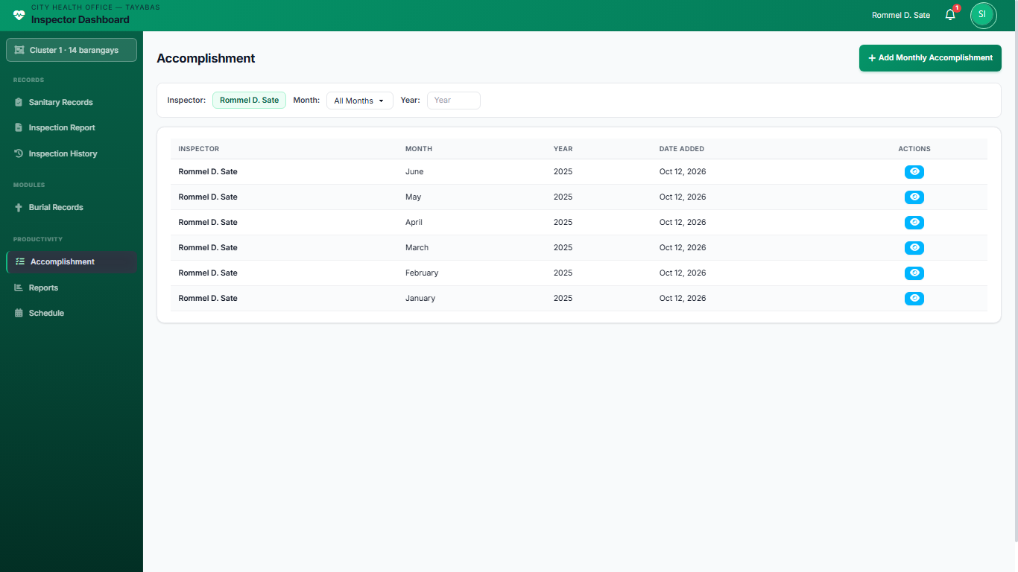
Figure 6. Accomplishment module.
- Module 5: Dashboard Module
The Dashboard (admin home screen) functioned as the primary control center. Its features include KPI cards for establishment and inspection counts, charts of violations and risk levels, recent activity and pending follow-ups, threshold-based alerts when an establishment crosses the violation limit, and quick links into Sanitary Records, Inspection Reports, Prescription (prediction), and other modules. Graphical views give rapid situational awareness so CHO staff can see where risk is concentrated and open the underlying records in one step.
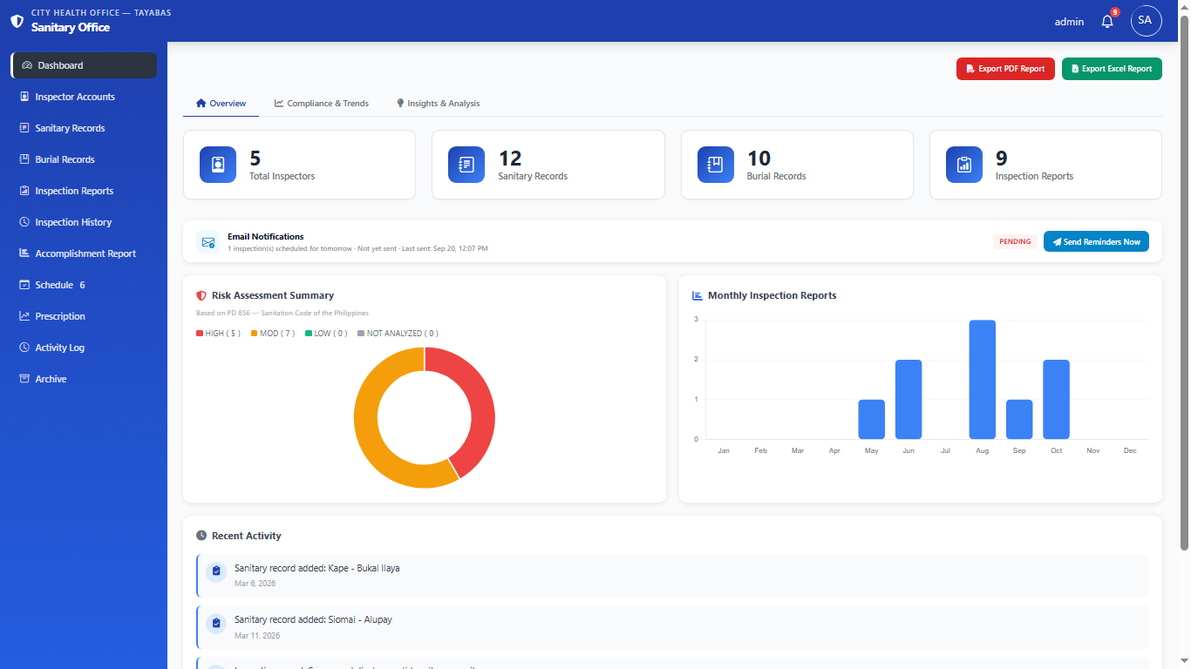Figure 7. Dashboard module.
- Module 6: Burial Records Module
This module recorded cadaver, skeletal, and exhumation entries for the City Health Office. Its features include adding and editing burial records with date, sex, and type; searching the list; and, on the inspector side, attaching a death-certificate file. Burial counts for the selected month also feed the automatic portion of the monthly accomplishment form.
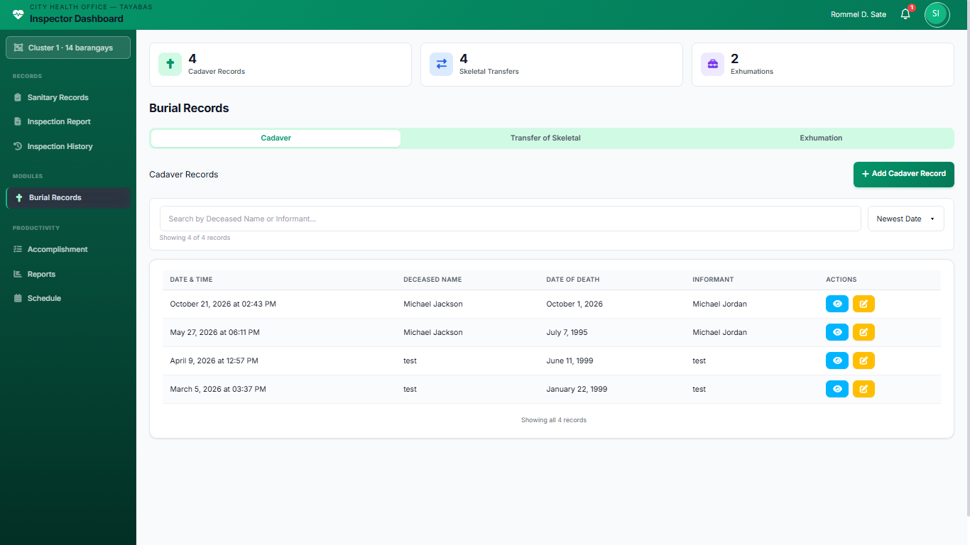
Figure 8. Burial records module.
- Module 7: Schedule Module
This module maintained inspection schedules on a monthly calendar. Its features include creating a schedule for an establishment and date, viewing day and month calendars with establishment chips, and assigning work according to the five fixed cluster partitions of the 66 barangays so each inspector sees the visits for their own cluster. Admin sees all clusters; inspectors see only theirs.
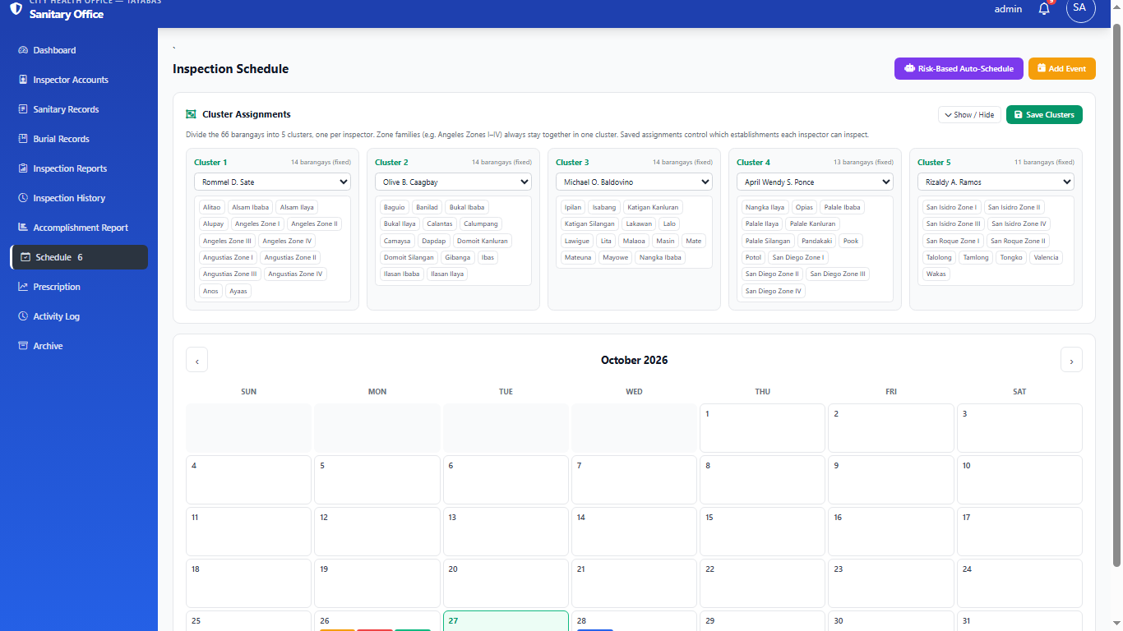
Figure 9. Schedule module.
- Module 8: Prescription Module (Risk Prediction)
This module presented the five-factor risk scores for establishments (admin side: Prescription). Its features include listing risk scores and HIGH / MODERATE / LOW levels, opening score breakdowns, and supporting the prescribed inspection intervals and actions used for re-inspection planning. Scores are computed by the rule-based engine from violations, time since last inspection, establishment category, compliance history, and pending follow-ups — not by machine learning.
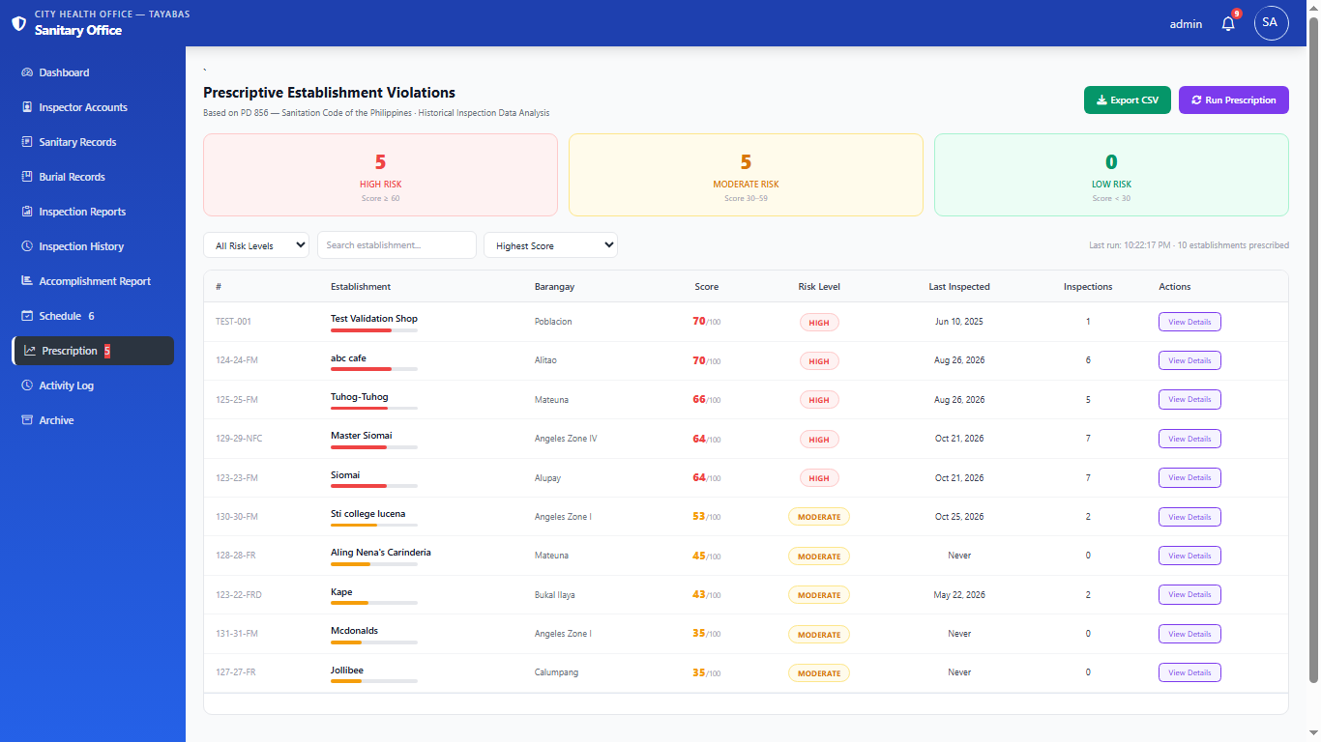
Figure 10. Prescription module.
- Module 9: Activity Log and Archive Modules
The Activity Log module showed the audit trail of sign-ins and data changes for accountability. The Archive module listed soft-deleted items so an administrator can restore a record or permanently delete it when required; ordinary delete actions elsewhere in the system send items here instead of erasing them immediately.
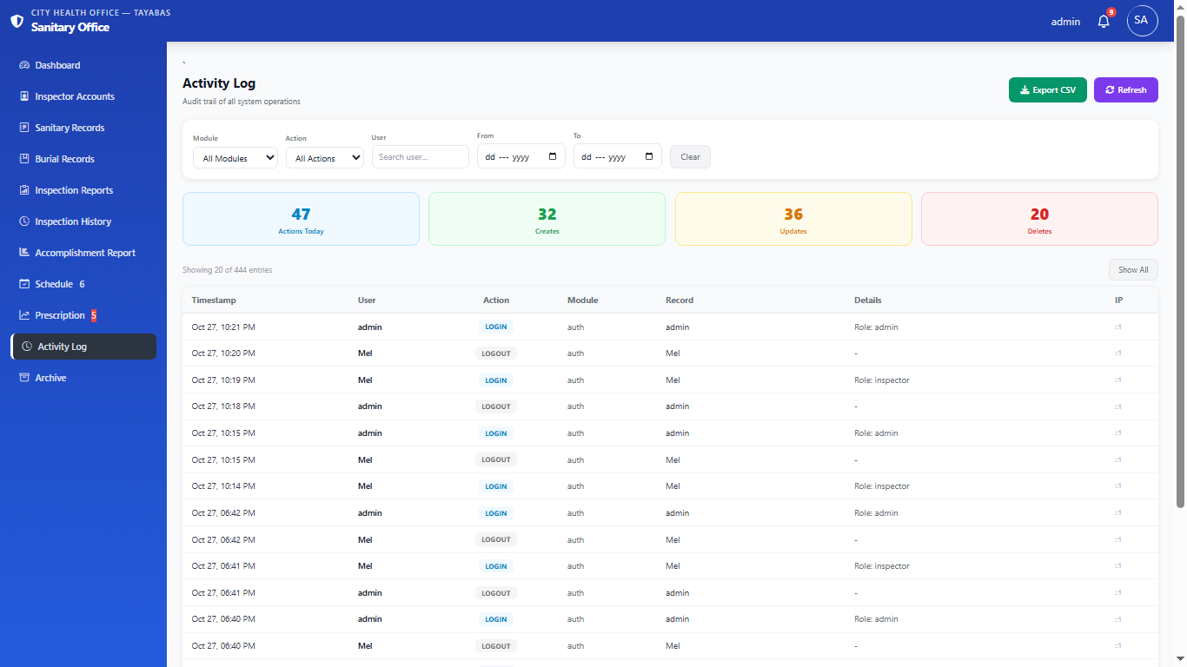
Figure 11. Activity log module.
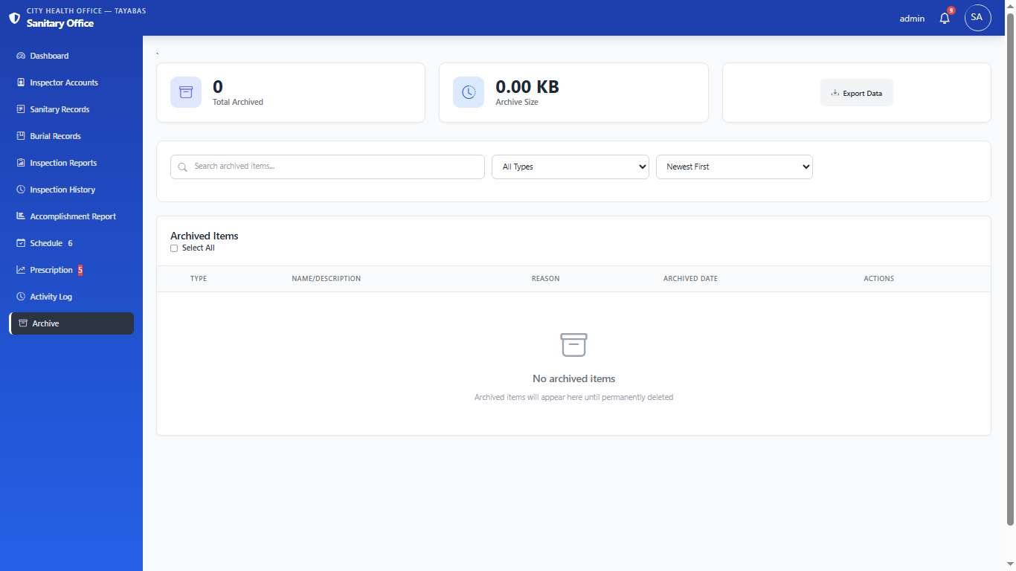
Figure 12. Archive module.

- Sanitary Permit Printing
The system can print a sanitary permit for an establishment recorded as compliant, showing the permit number, the establishment details, and the validity period printed on the form. The document is generated from the establishment record already held in the system, which removes the need to prepare the permit manually. The current version does not keep a separate registry of issued permits, does not track expiry dates, and does not send renewal reminders; these are identified as future work in the Recommendations.

Limitations of the study
The system is constrained to establishments within Tayabas City and focuses only on specific sanitation conditions recorded during inspection. Several limitations must be acknowledged to set appropriate expectations for system capabilities and boundaries.
- Internet Connectivity Dependency
The system requires stable internet connection for all operations. Slow or unstable connections may cause delays in page loading, timeout errors during report submission, or difficulty accessing the system. Field inspectors in areas with poor mobile data coverage may need to record findings manually and enter data later when connectivity is restored.
- Geographic and Jurisdictional Limitation
The system is specifically designed for Tayabas City and may require significant adjustments for other municipalities. System architecture, data structures, and compliance criteria are tailored to Tayabas City's organizational structure and local ordinances.
- Scope Restriction to Specific Sanitation Indicators
The system focuses on cleanliness, waste management, restroom facilities, and water supply, excluding other environmental health parameters such as air quality, occupational health conditions, or hazardous material handling. The selected indicators represent priority concerns for Tayabas City.
- Testing Status
The system was verified through internal quality-assurance checks performed by the developers, which covered the main user flows such as encoding an inspection, calculating a risk score, generating a report, and recording an activity-log entry. Formal unit, integration, system, and user-acceptance testing with City Health Office personnel has not yet been carried out, so the test results in Tables 11 and 12 are intentionally left unreported and no measured performance figure is claimed. The reported results should therefore be read as functional verification of a working prototype rather than as the outcome of a completed testing programme.
- Pilot Data Sample
The analysis presented in this study was drawn from a pilot set of digitized records rather than from the full history of the City Health Office, which monitors around 3,000 establishments. The sample used for the violation and risk analysis therefore covers only a small fraction of the establishments in the city, and the distributions and rankings reported in this chapter are indicative of the method rather than statistically representative of Tayabas City as a whole. Loading the remaining historical records is required before the risk classifications can be treated as citywide figures.

Review of related literature/studies/systems
Related Literature

Foreign
Digital transformation in environmental health monitoring has changed how municipalities collect and manage sanitation data. Web-based data collection can improve the accuracy and timeliness of environmental health reporting by reducing manual re-encoding and allowing authorized staff to retrieve records for decision-making. These systems can combine geographic context with environmental health indicators so that officials can see where sanitation issues concentrate and plan follow-up work more carefully. This supported the single-entry, web-based design of TayabasCare, which was intended to remove the manual re-encoding errors of the City Health Office's paper-based process (World Health Organization, 2021).
Environmental health monitoring systems may also use data analysis to identify recurring problems and help authorities plan their work. Historical inspection outcomes, violation records, complaints, and enforcement history are among the factors considered in some risk-based inspection approaches (Ze et al., 2024). These indicators can help identify establishments that may require closer review, but the suitability of each factor depends on the applicable regulations, the quality of the records, and validation by the responsible authority. This is relevant to the proposed TayabasCare system because its purpose is not only to store inspection information but also to help authorized personnel examine historical violations and consider appropriate follow-up actions. The digital inspection systems must also be usable, secure, and suited to the work practices of field personnel. The World Health Organization (2021) highlighted the importance of governance, appropriate technology, and the responsible use of digital information. Structured data-entry forms, validation rules, access controls, and traceable updates can help ensure that inspection results are consistently recorded. Automated reports can then be generated from the same stored records, while recommendations should remain linked to the relevant inspection finding and applicable rule.

Local
The Philippine context presents unique challenges for implementing environmental health data systems due to varying infrastructure capabilities across different localities. Studies on water, sanitation, and hygiene in the Philippines show that local governments must align digital reporting with national targets and with the capacity of each LGU (Molina et al., 2021). Needs-assessment research on food-service inspection in a Philippine LGU likewise stresses limited inspector capacity and the need for simpler, more consistent recording tools (Atif & MacDonald, 2021). Systems that fit existing Department of Health (DOH) reporting formats and Environmental Sanitation protocols reduce duplicate data entry and make compliance reporting more predictable. TayabasCare followed the same approach: the establishment data were encoded once, and the DOH-required monthly, quarterly, and yearly reports were generated from that single entry.
Municipal sanitation data management in the Philippines has historically relied on paper-based systems that create significant delays in identifying and responding to public health concerns. Manual compilation of monthly, quarterly, and yearly reports requires staff to re-enter the same establishment details across reporting periods, which slows turnaround and raises the risk of inconsistencies. Because Tayabas City belongs to the CALABARZON region, a centralized database with automated report generation directly addressed those reporting delays: one encoding pass feeds every required report format (Byrne and Heywood, 2023).

Related Studies

Foreign
Research on digital health information systems reports consistent gains in data completeness and reporting speed when records move from paper forms to structured electronic entry. Scoping reviews of routine health information systems show that software-supported data flow improves the availability of indicators used in district and facility planning (Byrne and Heywood, 2023). Comparative work on electronic health management information systems further reports measurable changes in data quality after digitization (Lwoga and Musheiguza, 2023). Broader reviews of hospital information systems similarly argue that electronic records reduce retrieval time and support safer, more timely use of clinical and administrative data (Smith-Mitchell, 2025). TayabasCare applied the same principle to sanitation inspection: structured forms, a single database, and automated monthly, quarterly, and yearly reports replaced repeated manual compilation. Threshold-based in-app alerts and inspection scheduling features operationalized those findings for the City Health Office, notifying administrators when violation counts exceeded configured limits and flagging follow-up actions that remained incomplete past their deadlines.
The integration of digital forms with validation rules has transformed how field data are captured and checked. Built-in constraints and standardized inputs reduce free-text inconsistencies that appear when inspectors transcribe paper notes later. Reviews of electronic health record adoption also emphasize that data-quality tools and clear workflow design are as important as the software itself (Alharbi, 2025). TayabasCare likewise used structured inspection forms, required fields, and photo or document uploads at the point of collection so that entries remained consistent before reports were generated.

Local
Implementation of digital health information systems in resource-limited local government settings often faces constraints such as limited IT infrastructure, intermittent connectivity, and competing staff priorities. Recent lessons from implementing electronic health records in resource-limited countries show that success depends on matching the design to local workflows, infrastructure, and staff habits rather than copying high-income templates (Ali et al., 2023; Faris et al., 2024). These constraints applied to TayabasCare: the system was built as a web application for a local government office with limited resources, and its reports were prepared for DOH compliance without requiring a large on-site server footprint.
Technological adoption in environmental health services depends on whether decision-makers can actually see and use the data that field staff collect. When inspection results flow into a shared dashboard, administrators can review violation trends, compliance statistics, and risk distributions without waiting for manual consolidations. That visibility supports resource allocation and follow-up planning. In the same way, the Dashboard Module of TayabasCare gave City Health Office administrators visibility of inspection metrics, violation trends, and risk distributions to support data-driven decisions and resource allocation (Smith-Mitchell, 2025).

Related Systems

Foreign
Environmental health management platforms (United States and international vendors)
Commercial environmental health management platforms marketed to local and state health departments offer modules for inspection scheduling, complaint tracking, permit records, and regulatory reporting. Vendors in this space commonly describe mobile field applications, workflow automation, GIS overlays, and customizable dashboards. Like those platforms, TayabasCare combined inspection documentation, reporting, and dashboards in one web application, but it focused on the sanitation inspection of establishments under the City Health Office rather than on a multi-agency EHS suite sold to U.S. counties.
Municipal sanitation and waste-tracking systems (international practice)
Municipal governments in several countries use web-based sanitation and waste-tracking systems to schedule routine inspections, log facility conditions, and analyze service trends. Those products emphasize citizen reporting portals, automated scheduling, and analytics for sanitation hotspots. Like those systems, TayabasCare scheduled routine inspections automatically and set the inspection frequency according to each establishment's risk level, while staying scoped to CHO establishment sanitation rather than citywide waste collection.

Local
Municipal health information systems (Philippines)
Philippine local government units have adopted municipal health information systems that combine patient or client records, health program monitoring, and environmental health tracking. Typical implementations emphasize DOH-aligned reports, multilingual labels, and low-bandwidth operation. TayabasCare also generated the DOH reports, but it drew them from inspection data that were entered only once and it was dedicated to sanitation inspection rather than to general health records.
City environmental health monitoring systems (highly urbanized cities)
Highly urbanized cities in the Philippines have deployed environmental health monitoring systems with modules for sanitation facility inspections, water quality monitoring, vector surveillance, and complaint handling. Those systems commonly include role-based access, automated notices, public rating views, and GIS features. TayabasCare similarly applied role-based access through its User Management Module, and it was scaled for the smaller, resource-constrained setting of Tayabas City rather than for a highly urbanized city.

Synthesis
The reviewed literature, studies, and systems collectively demonstrate that web-based environmental health data collection systems can improve data accuracy, reporting efficiency, and decision support when they match local workflows. Recent international research on health information systems (2023–2025) shows structured digital entry reducing re-work and improving data completeness, while Philippine WASH and local inspection sources stress alignment with DOH formats and realistic LGU capacity (Atif & MacDonald, 2021; Molina et al., 2021). Agile methodology sources further support iterative delivery with stakeholder feedback (Desai et al., 2024; Thesing et al., 2021; Kokol, 2022).
These findings were connected to TayabasCare feature by feature. The single-entry encoding and automated monthly, quarterly, and yearly reports followed the literature on reduced duplicate data entry and faster routine reporting (Byrne and Heywood, 2023; World Health Organization, 2021). Structured validation at the point of capture followed the data-quality concerns discussed in electronic record adoption studies (Alharbi, 2025). Dashboard visibility followed the principle that managers need timely indicators rather than delayed manual consolidations (Smith-Mitchell, 2025). The reviewed system families—commercial environmental health platforms, municipal sanitation trackers, Philippine municipal health information systems, and city environmental health monitors—supported the inspection, scheduling, reporting, and role-based access modules of TayabasCare.
Existing systems reveal common essential features including automated workflows, offline or low-bandwidth accommodations where available, citizen or client portals in some products, and compliance reporting tools. However, foreign systems are designed for different regulatory frameworks, while local systems either take overly broad comprehensive approaches or are scaled for highly urbanized city contexts. TayabasCare addressed this gap by synthesizing proven features from existing systems while providing exclusive focus on environmental health and sanitation, specific customization for Tayabas City's component city structure, and optimization for resource-constrained Philippine LGU environments. As described in this review, the distinguishing feature of TayabasCare is the use of historical inspection records to compute risk scores that prioritize establishments for inspection. TayabasCare added this through its rule-based risk scoring grounded in PD 856, which classified establishments as low, moderate, or high risk.

METHODOLOGY
The proponents utilized the Agile Methodology, specifically the Iterative Agile Model, throughout the development of TayabasCare: Prescriptive Establishment Violations Using Historical Inspection Data for City Health Office of Tayabas City to ensure that the system was built efficiently and continuously improved.
Objective 3 (provide a web-based inspection and documentation platform) is met by the Inspection Report module, Inspection History, and role-based access for the admin and inspector accounts. Objective 4 (automated risk assessment and notification) is met by threshold-based in-app alerts and the optional email notification runner, with inspection intervals derived from the computed risk level. Objective 5 (analytical dashboards and reporting) is met by the Dashboard module and the PDF, Excel, and CSV export functions. The specification is intentionally implementation-aligned: every mapped feature exists in the deployed system, and features outside this scope are listed only under Limitations and Recommendations.
The system design specification maps each study objective to the module or feature that satisfies it. Objective 1 (digitize historical inspection records) is met by the Sanitary Records module and the Import Historical Records and Import Inspections functions, which load establishment profiles and inspection reports into a single database. Objective 2 (analyze records and establish risk criteria) is met by the rule-based risk scoring engine in risk_utils.php, which scores five weighted factors grounded in Presidential Decree No. 856 rather than by machine learning.
- System design specification
The system employed a rule-based prescriptive scoring engine grounded in Presidential Decree No. 856 (Code on Sanitation of the Philippines), which calculated a risk score for each establishment using five weighted factors: number of previous violations, time since last inspection, establishment category, compliance history percentage, and pending follow-up action completion. An AI-powered narrative layer supplemented the scoring engine by generating plain-language risk assessments for inspectors and administrators.
The proponents divided the project into multiple iterations, where each cycle includes stages such as planning, designing, developing, testing, deploying, reviewing and launching. This approach allowed the proponents to focus on smaller, manageable goals in every phase, making it easier to track progress and adapt to any changes or feedback from the users. By following this method, the proponents produced a functional system early in the process and enhance it through constant refinement. Agile methodology was applicable to the proponents because it promoted flexibility, collaboration, and consistent communication which helped in handling revisions and unexpected challenges during the development of the system. According to Desai et al. (2024), iterative Agile processes in software and healthcare settings increase project efficiency and user satisfaction because they enable dynamic adjustment and ensure that every iteration delivers measurable value to stakeholders.
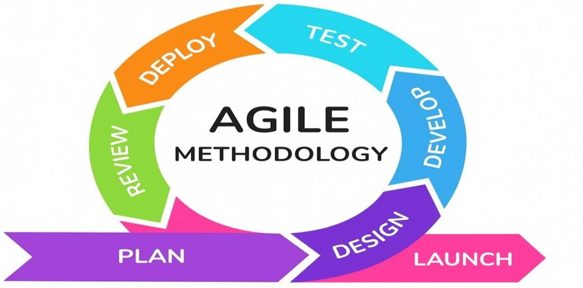
Figure 13. Agile methodology framework diagram.
Compared to other methodologies, Agile was more suitable for this project than the Waterfall Model because it allows flexibility and adapts quickly to user feedback, enabling continuous improvement. In contrast, Waterfall follows a rigid, linear process where changes require revisiting earlier stages, making it less efficient for projects that evolve during development (Thesing et al., 2021; Kokol, 2022). This adaptability ensured the system aligns closely with user needs and operational goals.
The proponents used a sprint-based schedule to organize and track the development of the system. Each sprint lasted for two weeks, giving enough time to plan, create, test, and improve specific parts of the project. After every sprint, the proponents reviewed the progress and made changes as needed. This schedule helped keep the work organized and ensured continuous improvement of the system.
The Agile process has seven main phases which are the Planning Phase, Designing Phase, Development Phase, Testing Phase, Deployment Phase, Review Phase and Launch Phase. These phases are connected to one another and are repeated whenever improvements are needed. Through this process, the proponents could make sure that the system is properly developed and functions well according to the expectations of the City Health Office of Tayabas City.

Planning Phase
In the Planning Phase, the proponents identified the goals and scope of the project. The proponents outlined the objectives of TayabasCare and determined the features needed for the web-based sanitation environmental health data collection and reporting system for Tayabas City. The proponents gathered relevant data by conducting interviews with City Health Office staff, environmental health officers, and establishment owners, observing the current data collection and reporting process, and reviewing existing records and sanitation inspection procedures. The proponents analyzed this data to understand the system requirements and identify any potential challenges. This phase helped the proponents establish a clear roadmap for development and ensured that the system met the needs of the City Health Office and the establishments being monitored.
Designing Phase
In the Designing Phase, the proponents created the overall structure and layout of TayabasCare. The proponents developed detailed system designs, including interface layouts, database schemas, and workflow diagrams, to ensure the system is functional and user-friendly. The design was built to meet the specific requirements of the City Health Office, ensuring that the system supported efficient data collection, sanitation inspection management, report generation, and establishment information accessibility. The proponents also prepared prototype interfaces and design documents for client review and approval, ensuring that all aspects of the system aligned with the operational needs of the City Health Office and comply with sanitation standards and regulations.
Developing Phase
In the Developing Phase, the proponents began building TayabasCare based on the designs created in the previous phase. The proponents wrote the necessary code, configure the database, and integrated the system's features to ensure it functioned as intended.
The proponents implemented key modules, including the data collection system, establishment profiling, sanitation inspection records, prescriptive risk scoring engine, reporting and analytics dashboard, and other essential components of the system, following the approved design closely.
Testing Phase
During this phase, the proponents conducted initial tests to verify that each feature worked correctly and met the requirements of the City Health Office. The proponents ensured that the system was reliable, efficient, and ready for the next phase, addressing any issues or bugs that arose to maintain system quality and functionality.
The proponents evaluated all components of TayabasCare to ensure the system functioned according to the design specifications. Unit, integration, and system testing were conducted to verify that all modules, including the data collection system, establishment profiling, sanitation inspection records, prescriptive risk scoring engine, and reporting dashboard, operated correctly and seamlessly. Any identified errors or bugs were corrected to improve performance. A stress test was also conducted to assess how the system handles high volumes of data entries, multiple concurrent users, or heavy reporting workloads, ensuring reliability, stability, and efficiency under various conditions, and confirming that the system was ready for deployment.
Deploying Phase
The proponents finalized all components of TayabasCare and ensured that the system was fully tested and validated. The system was installed on the server, user accounts were configured, and access was provided to authorized users from the City Health Office and registered establishments. All modules, including the data collection, establishment profiling, sanitation inspection, prescriptive risk scoring, and reporting systems, were made fully operational and integrated with the existing workflow. The proponents provided guidance and training to environmental health officers and establishment representatives on how to operate the system effectively, monitor system performance, and address any issues to ensure a smooth transition from development to full operation.

Reviewing Phase
After the system is deployed, the proponents observed its performance and collect feedback from the users. The proponents also made minor adjustments and provide maintenance when needed to keep the system running smoothly. This phase marks the operationalization of the system, as the City Health Office used the system to collect, manage, and report sanitation environmental health data for establishments in Tayabas City more efficiently.
Launching Phase
The proponents released TayabasCare for full operation and made the system accessible to all intended users. The initial use was monitored to ensure that all features, including the data collection, establishment profiling, sanitation inspection records, prescriptive risk scoring, and reporting modules, functioned smoothly under real-world conditions. Feedback from City Health Office staff and sanitary officers was gathered to identify any issues or areas for improvement. Any necessary adjustments or updates were applied to enhance system performance, reliability, and user satisfaction, ensuring that TayabasCare operated effectively and meets its intended purpose of improving sanitation environmental health monitoring in Tayabas City.

RESULTS AND DISCUSSIONS
This chapter presents the results of the development and testing of TayabasCare, a web-based prescriptive system for the City Health Office of Tayabas City. TayabasCare applies a rule-based scoring engine grounded in Presidential Decree No. 856 (Code on Sanitation of the Philippines) to historical inspection records. The engine assigns each establishment a risk level, an inspection priority and interval, and a recommended action. It does not use machine learning. The results follow the five specific objectives of the study. Sample raw data are shown in the tables, and the full data set is in the appendix.
Digitization of Historical Inspection Records
The scattered paper-based and manually kept records of the City Health Office, which monitors approximately 3,000 establishments, were consolidated into one structured database. Records were encoded through the digital forms or loaded in bulk through the Import Historical Records function for establishment profiles and the Import Inspections function for inspection reports. Each establishment profile stores its business type, barangay, permit details and health certificate results. Each inspection report stores its date, status, compliance result and recommendation. Every edit to a report is kept in Inspection History, so earlier versions are not lost.
Table 1. Data encoding before and after the system
Reporting task | Manual process | TayabasCare
Monthly, quarterly and yearly reports | The same establishment data is encoded at least three times, once per reporting period (interview with the Sanitation Inspector V) | Data is encoded once and reused for all reports
Sanitary permit and report preparation | Prepared separately by hand | Generated from the same stored record
Retrieval of past inspections | Searching physical files | Search and sort in Sanitary Records and Inspection History
Table 2. Summary of digitized records
Record type | Count
Establishment profiles (sanitary records) | 10
Inspection reports | 8
Saved report versions (Inspection History) | 33, from 6 reports
Barangays covered | 7
Period covered by inspection reports | June 1, 2025 to September 13, 2026
Burial records | 15
Monthly accomplishment records | 30 (5 inspectors, January to June 2025)
Bulk import operations recorded in the Activity Log | 1
Table 3. Sample of digitized raw data
Establishment | Business type | Barangay | Inspection date | Complied | Recommendation
Aling Nenas Carinderia | Other | Mateuna | June 1, 2025 | Yes | Complied with all
Kape | Other | Bukal Ilaya | May 22, 2026 | No | Provide trashcan
Siomai | Other | Alupay | August 8, 2026 | No | Provide and enforce use of appropriate PPE for all food handlers
abc cafe | Other | Alitao | August 26, 2026 | No | Secure and display a valid sanitary permit
Tuhog-Tuhog | Other | Mateuna | August 26, 2026 | No | Secure and display a valid sanitary permit
A total of 10 establishment profiles and 8 inspection reports were digitized (Table 2), together with 33 saved report versions, 15 burial records and 30 monthly accomplishment records. The database currently holds 10 of the approximately 3,000 establishments under the City Health Office. The remaining records can be loaded with the same import function. Records that were once filed by hand can now be found through the search box and sort options. Table 1 shows the main gain. The repeated encoding that the City Health Office described as its primary operational problem is replaced by a single entry that feeds every report. Three data quality problems common in manual records were handled by the system:
- Different spellings of one name. The system links an inspection record to an establishment by name matching, including partial matches, so small spelling differences do not split one establishment into two.
- Repeated versions of one report. When several versions of the same report date exist, only the latest is used for scoring, so one inspection is not counted twice.
- Wrong future dates. A report dated in the future is treated as a data error and given the highest "time since last inspection" penalty, so it cannot make an establishment look recently inspected.
Violation Patterns and Risk Scoring Criteria
The digitized records were analyzed in the Insights & Analysis tab of the dashboard, which groups violations by establishment category, barangay and violation type.
Table 4. Violations by establishment category
Category | Establishments | Inspections not complied | Share of all violations (%)
Other | 9 | 5 | 71.4
Retail Store | 1 | 1 | 14.3
Not linked to an establishment record | 0 | 1 | 14.3
Total | 10 | 7 | 100
Table 5. Establishments and violations by barangay
Barangay | Establishment records | Inspections not complied
Mateuna | 3 | 1
Alitao | 1 | 1
Alupay | 1 | 1
Angeles Zone IV | 1 | 1
Bukal Ilaya | 1 | 1
Angeles Zone I | 0 | 1
Angeles Zone II | 1 | 0
Calumpang | 1 | 0
Table 6. Most common violation types
Rank | Violation type | Occurrences
1 | No sanitary permit | 3
2 | Waste disposal (no trashcan) | 1
2 | Food handling (no PPE for food handlers) | 1
2 | Water and sanitation (no handwashing station) | 1
2 | Other (general "needs improvement") | 1
Of the 8 inspection reports, 7 were not complied with, and these are counted as violations in Tables 4 to 6. Violation codes were not recorded in the reports, so Table 6 groups the inspectors' written recommendations into the system's violation categories. With so few inspections, the rankings are indicative only: Mateuna has the most establishment records (3), two of which have a violation, while every other barangay with a violation has exactly one. Table 5 lists six of the seven violations by barangay; the seventh was entered without a valid barangay.
From these patterns, a risk score from 0 to 100 was defined using the five measurable factors named in the study objectives (Table 7). The score classifies each establishment into one of three risk levels (Table 8).
Table 7. Risk scoring criteria
Factor | How it is measured | Points
Previous violations | 8 points per inspection that was not complied with, or whose remarks contain a violation keyword (for example "dirty", "pest", "garbage", "expired", "no permit") | 0–25
Time since last inspection | 30 days or less = 0; 31–60 = 5; 61–90 = 10; 91–180 = 15; over 180 days or never inspected = 20 | 0–20
Establishment category | High-risk (food, health, lodging, personal-care) = 20; medium-risk (retail, school, office, warehouse) = 12; other = 5 | 5–20
Compliance history | (1 − compliance rate) × 20; no inspection on record = 10 | 0–20
Pending follow-up actions | 5 points per pending or "for follow-up" inspection, or unresolved health certificate result (X-ray or stool) | 0–15
Total |  | 0–100
Table 8. Risk level classification
Risk level | Total score
HIGH | 60 and above
MODERATE | 30 to 59
LOW | Below 30
The weights assign the highest contribution to repeated violations up to 25 points and give high-risk establishment categories up to 20 points because food- and health-related establishments can pose greater public health risks under Presidential Decree No. 856. The weights are heuristic and were derived from the risk tiers of PD 856 rather than from a fitted statistical model; a formal expert validation of the weights has not yet been conducted (see Limitations of the study). The formula is transparent and auditable. Each score is shown with its factor breakdown, allowing inspectors and administrators to see why an establishment is classified as HIGH, MODERATE, or LOW. This is an advantage over a black-box model and is consistent with the study's use of rule-based scoring rather than machine learning.
TayabasCare Web-Based Platform
TayabasCare was implemented as a web-based platform with two user roles. Administrators use the dashboard, sanitary records, inspection reports, inspection history, the Prescription page, the schedule, inspector accounts, the activity log, the archive and the accomplishment report. Inspectors use sanitary records, the digital inspection form, inspection history, burial records, the schedule and the accomplishment report. The inspection form has a violation checklist, a recommendation checklist and an option to upload or scan a photo of the inspection paper as supporting documentation. Authorized personnel can also print the sanitary permit of an establishment from its record.
Table 9. Implementation of the five system modules
Module | Implemented features
User Management | Inspector account creation and management, role-based access, login and password recovery
Establishment Registration | Add, edit, search, sort, import and archive establishment profiles; sanitary permit printing
Inspection and Data Collection | Digital inspection form with violation and recommendation checklists, photo upload, form draft saving, inspection history, burial records
Reporting | Inspection report import and export (CSV, Excel, PDF), accomplishment report, dashboard export (PDF, Excel)
Dashboard | Overview, Compliance & Trends and Insights & Analysis tabs with charts and filters
Table 10. Security and access control features
Feature | Description
Role-based access | Inspectors are blocked from administrator pages
Password protection | Passwords are stored as hashes; minimum length of 8 characters
Request protection | Forms are protected with CSRF tokens; the session is renewed at login
Idle auto-logout | Users are logged out after 30 minutes of inactivity
Draft saving | In-progress inspection and sanitary forms are saved automatically so they survive an auto-logout
Password recovery | One-time password (OTP) sent to the registered email
Audit trail | The Activity Log records user actions with date and time; deleted records go to the Archive
Following the Testing Phase of the methodology, the modules were tested for correct function. Table 11 shows the results.
Table 11. Unit, integration and system test results
No. | Test case | Expected result | Result
1 | Log in with valid credentials | User enters the dashboard for their role | Not reported
2 | Log in with a wrong password | Login is refused with an error message | Not reported
3 | Inspector opens an administrator page | Access is blocked | Not reported
4 | Import historical records file | Records are saved to the database | Not reported
5 | Save a new inspection with checklist and photo | Report appears in Inspection Reports | Not reported
6 | Search and sort establishments | Matching records are shown in the chosen order | Not reported
7 | Edit an existing report | Previous version appears in Inspection History | Not reported
8 | Perform any action in the system | A matching entry appears in the Activity Log | Not reported
9 | Delete a record | Record moves to Archive | Not reported
Table 12. Stress test results
Test | Load | Observed result
Concurrent users | Not reported | Not reported
Large record volume | Not reported | Not reported
Heavy reporting | export of records | Not reported
Formal unit, integration, and system test execution has not yet been completed, so no pass/fail count or measured stress-test value is reported in Tables 11 and 12 (see Limitations of the study). The platform brings records, scores, and schedules together in one system. The Activity Log recorded 251 actions by 3 users, including 161 logins, 26 updates, 19 logouts, 15 creations, 10 deletions, 3 restorations, and 1 import. Five deleted records were retained in the Archive. A report saved by an inspector is available to the administrator, and the action is logged. Role-based access controls restrict administrator pages, while the protections listed in Table 10 help secure records and document user actions. The system depends on a stable internet connection. Draft saving reduces the effect of a lost session, but inspectors in areas with poor connectivity may still need to record findings on paper first.
Automated Risk Assessment and Notifications
When Run Prescription is clicked, the system calculates the score for every establishment and classifies it as LOW, MODERATE or HIGH.
Table 13. Risk level distribution of establishments
Risk level | Establishments | Percentage (%)
HIGH | 5 | 55.6
MODERATE | 4 | 44.4
LOW | 0 | 0.0
Total | 9 | 100
Table 14. Highest-risk establishments with score breakdown
Establishment | Violations (25) | Time since last (20) | Category (20) | Compliance (20) | Follow-up (15) | Total | Level
abc cafe | 25 | 20 | 5 | 10 | 10 | 70 | HIGH
Test Validation Shop | 8 | 20 | 12 | 20 | 10 | 70 | HIGH
Tuhog-Tuhog | 25 | 20 | 5 | 16 | 0 | 66 | HIGH
Master Siomai | 24 | 20 | 5 | 15 | 0 | 64 | HIGH
Siomai | 24 | 20 | 5 | 15 | 0 | 64 | HIGH
The risk level sets how often an establishment should be inspected (Table 15), and the intervals are read from a configuration table in the database. The auto-scheduler adds an establishment to the schedule only when it is overdue for its interval and has no pending schedule already. The schedule is ordered with HIGH first.
Table 15. Inspection interval by risk level
Risk level | Inspection interval
HIGH | Every 30 days
MODERATE | Every 90 days
LOW | Every 180 days
The system also prescribes an action for each establishment, which is the prescriptive part of TayabasCare.
Table 16. Prescribed actions
Condition | Prescribed action
Food or health establishment with violations | Prioritize PD 856 compliance review
Repeated violations (violation score of 16 or more) | Immediate re-inspection
Not inspected for over 3 months, with unresolved follow-ups | Schedule immediately
Not inspected for over 3 months | Schedule an inspection
Persistent non-compliance | Escalate to the City Health Officer
Low compliance history | Inspector follow-up and enforcement
No concerns found | Continue routine monitoring
An AI-assisted narrative layer supports the scoring engine. For a selected establishment, it writes a short plain-language assessment that explains why the establishment has its risk level and what the City Health Office should do, using the score, violation count, last inspection date and the system recommendations. The narrative does not change the score or the risk level. Requests are limited to 10 per hour per user, and results are stored so the same establishment is not analyzed again unnecessarily. The narrative is a writing aid and can be imprecise. The sample in Table 17 says the last inspection was over two months ago, although the report is dated June 2025, so inspectors should always check it against the score breakdown.
Table 17. Sample system-generated risk narrative
Establishment | Risk level and score | AI assessment
Test Validation Shop | HIGH / 70 | The shop has a single violation from June 2025 and its last inspection was over two months ago, indicating long-overdue compliance. Because it already recorded a violation and shows low compliance history, it poses a high risk of continued non-conformance and potential public health hazards. The City Health Office should schedule an immediate reinspection, require corrective action documentation, and enforce penalties until full compliance is achieved.
Personnel are notified automatically (Table 18).
Table 18. Automated alert and notification rules
Alert | Trigger | Severity | Delivery
High risk | Score of 60 or above | Critical | In-system alerts; daily compliance alert email to the administrator
Violation threshold | 3 or more violations (5 or more is critical) | Warning / Critical | In-system alerts; daily compliance alert email to the administrator
Overdue follow-up | Follow-up inspection more than 14 days past due | Warning | In-system alerts
Upcoming inspection | Scheduled inspection within the next 3 days | Info | In-system alerts; email reminder to the assigned inspector
Table 19. Sample notification log
Date sent | Type | Recipient | Status | Count
September 20, 2026 | Compliance alert | Administrator | Sent | 2
The results show that 5 of 9 establishments (55.6%) were classified HIGH risk and 4 (44.4%) MODERATE, with none LOW (Table 13). The 9 alerts stored in the system match this result: 5 high-risk alerts (critical), 3 violation-threshold alerts (2 warning, 1 critical) and 1 overdue follow-up alert (information). The system therefore directs inspectors to these establishments first, so limited inspection resources go where compliance concerns are most likely. Inspection frequency follows the risk level, with 30-day visits for HIGH, 90-day for MODERATE and 180-day for LOW (Table 15). The prescribed actions (Table 16) tell the inspector what to do next, not only the rating. A notification log prevents duplicate emails on the same day, so personnel are not flooded with repeated messages. The log shows 2 compliance alert emails sent on September 20, 2026 (Table 19). No inspection reminder email has been logged yet, because the 17 schedules on record are all marked done. Sending email requires an internet connection and a working email account. Fully automatic daily sending depends on a scheduled task (such as Windows Task Scheduler) running on the server once the system is deployed.
Analytical Dashboards and Reports
The dashboard turns the raw records into charts and statistics in three tabs.
Table 20. Dashboard components
Tab | Contents | Filters
Overview | Total counts, risk level distribution chart, monthly inspections chart | None
Compliance & Trends | Violations by barangay chart, violation type chart | Date range (From/To) and barangay
Insights & Analysis | Pattern charts by category and barangay, year-over-year comparison | Year selection
Table 21. Report and export functions
Module | Output formats | Content
Dashboard | PDF, Excel | Statistics and charts summary
Inspection Reports | CSV, Excel, PDF | Inspection records
Accomplishment Report | Printable report | Inspections completed by each inspector
Prescription | CSV | Risk ranking of establishments with scores
Of the 8 recorded inspections, 7 were not complied with, and no barangay stands out: Alitao, Alupay, Angeles Zone I, Angeles Zone IV, Bukal Ilaya, and Mateuna have one non-compliant inspection each (Table 5). The most common violation is the lack of a valid sanitary permit, accounting for 3 of the 7 non-compliant inspections (Table 6). By year, non-compliant inspections increased from 1 in 2025 to 6 in 2026; however, the 2025 figure covers only two reports made in June 2025, so this comparison is indicative only. These findings can help administrators identify barangays and establishment categories to prioritize once the full set of records is loaded. Exportable PDF and Excel reports (Table 21) can be provided to City Health Office leadership. The Accomplishment Report contains 30 monthly records for 5 inspectors covering January to June 2025, supporting workload monitoring. Administrators can use these recorded data to inform decisions rather than relying on manual observation alone.
CONCLUSION
This chapter shows the summary, conclusion, and recommendation of the study titled TayabasCare: Prescriptive Establishment Violations Using Historical Inspection Data for City Health Office of Tayabas City.
Summary
This study was conducted to help the City Health Office of Tayabas City, which monitors around 3,000 business establishments. Before the study, the office relied on paper and manual encoding, and inspectors had to type the same information three times for the monthly, quarterly, and yearly reports. Because of this, work became slow, records became inconsistent, and reports were delayed.
For the first objective, the proponents gathered and organized previous inspection files and placed them into a single digital database. Old files from papers and spreadsheets were reviewed and encoded into a structured system. After this process, business details, past violations, and inspection dates were stored in one location. This made searching faster and prevented loss of important documents.
For the second objective, the proponents analyzed past records to identify common issues and patterns. Findings showed that certain types of businesses commit more violations, and previous records can indicate which ones are likely to commit again. Most cases were related to PD 856, such as lacking health cards, poor sanitation, and missing sanitary permits. Based on this, the developers created a simple risk scoring system using number of violations, frequency of occurrence, business category, and compliance history. Through this method, firms were grouped into low, moderate, and high risk, so inspectors can prioritize which ones to visit first.
For the third objective, TayabasCare was built as a website composed of five main modules: User Management for log-in and roles, Sanitary Records for listing establishments, Inspection Report for documenting results, Reporting for automatic report generation, and Dashboard for displaying data in charts. The platform automatically calculates risk scores, reminds personnel of inspection schedules, validates inputs, and keeps an audit trail. The one-time entry design removed repeated encoding, shortened the steps needed to produce a report, and placed the office's records in a single place for decision-making.
For the fourth objective, the system automatically calculated a risk score for each establishment, classified it as low, moderate, or high risk, and used that classification to prioritize inspections. Automated alerts and notifications were generated when inspections were due, when violations passed the threshold limit, and when follow-up actions remained incomplete, so limited inspection time could be directed first to the establishments most likely to be non-compliant.
For the fifth objective, the system presented violation trends, compliance statistics, and risk distributions through dashboards and produced exportable PDF, Excel, and CSV reports. These analytical views converted raw inspection records into information that City Health Office administrators could use for monitoring and for evidence-based decisions.

Conclusion
Consolidating the paper records of the City Health Office into a single digital database improved how the office stores and retrieves establishment information. Manual encoding was identified as the main reason for slow work and inconsistent data, and single-entry recording removed that redundancy.
Analysis of historical inspection data showed that violation patterns can be measured and used to build a prescriptive risk score. Establishment type and compliance history were found to be strong indicators of future violations. The rule-based scoring based on PD 856 is transparent and auditable, which classified establishments into low, moderate, and high-risk, shifting inspection from reactive to proactive.
TayabasCare was developed with the features needed for recording, monitoring, and automated reporting. Internal quality-assurance checks confirmed that single-entry recording eliminated redundant encoding, that earlier report versions are retained in Inspection History, and that reports are generated from the stored records; formal unit, integration, and system testing has not yet been executed, so no pass/fail claim is made here. The features directly address the daily requirements identified by the sanitation inspectors during the interview.
Automated risk assessment shifted the inspection approach from reactive to proactive. Because the scoring is rule-based and grounded in PD 856, every score can be explained through its factor breakdown, and the threshold alerts and schedule reminders give inspectors a documented basis for prioritising establishments.
Dashboards and exportable reports gave the City Health Office a consolidated view of inspection activity, violation trends, and risk distribution that was previously assembled by hand. The recorded data can therefore be used directly in monitoring and in evidence-based decisions instead of relying on manual observation alone.
Recommendation
The City Health Office is advised to implement TayabasCare in its routine workflow. Adequate capacity-building sessions should be provided to inspectors and administrative staff to ensure effective handling of profiling, documentation, and interpretation of risk analytics.
For technical improvement, development of a mobile version with offline capture and auto-sync capability is suggested to address areas with limited connectivity. Incorporation of geotagging to locate firms on a map and automated notification via SMS or email for permit renewal reminders will further elevate monitoring efficiency.
For the validation of the study, formal user-acceptance testing with City Health Office inspectors and administrators should be conducted before full deployment, and the scoring weights should be reviewed by sanitation specialists so that the risk classifications can be confirmed against expert judgement.
For future investigators, broadening the dataset to cover additional years and expanding coverage beyond Tayabas City is encouraged to refine the accuracy of the risk model. Further refinement of the prescriptive scoring criteria and risk indicators is recommended to improve the accuracy of risk prediction while retaining the current transparent, rule-based logic grounded in PD 856. Integration with related processes such as health certification, water analysis results, and waste management monitoring is also proposed to evolve TayabasCare into a comprehensive environmental health information system.

Hardware/Software Resources
The hardware and software components listed below are essential to the development and implementation of the system. These resources provide the necessary support to ensure the system functions efficiently and meets the needs of the users. Each hardware and software has a specific purpose in the development and operation of the web-based system.
Hardware
Laptop Computers – This device was used by the proponents as the main devices for coding, designing, and documentation. This device allows the proponents to run development tools, access software applications, and manage all aspects of the project efficiently.

Figure 14. Lenovo laptop.

Laptop 1: Lenovo
- Processor: AMD Ryzen 5 6600H with Radeon Graphics(3.30 GHz)
- Installed RAM: 8.00 GB
- Operating System: Windows 11 Home Single Language
- Storage: 475 GB

Figure 15. Asus laptop.

Laptop 2: Asus
- Processor: Intel(R) Celeron(R) N4020 CPU @ 1.10GHz

- Installed RAM: 8.00 GB
- Operating System: Windows 11 Home Single Language
- Storage: 474 GB

Figure 16. HP laptop.

Laptop 3: HP
- Processor: AMD Ryzen 3 2200U with Radeon Vega Mobile Gfx
- Installed RAM: 4.00 GB
- Operationg System: Windows 10 Pro
- Storage: 237 GB

Smartphone – This device was used by the proponents to communicate quickly, check emails, and access project files on the go. This device is also used to test the responsiveness and functionality of the system on mobile devices, ensuring it works properly for all users.

Figure 17. Redmi Note 12 smartphone.

Smartphone: Redmi Note 12
  - Processor: Snapdragon 685 Octa-core Max 2.80GHz
  - Installed RAM: 8 GB (4GB Expendable)
  - ROM: 256 GB
  - Operating System: Android 13 with MIUI 14

Software

Figure 18. Microsoft Word v.2404.
Microsoft Word v.2404 – This was used by the proponents to write, edit, and format the project documentation and reports. It serves as the main tool for creating written content, including the thesis, progress reports, and final submission. Using Word helps the proponents organize their work clearly, apply proper formatting, and present their findings in a professional and readable manner.


Figure 19. Figma.

Figma – This was used by the proponents to design and prototype the system’s layout and user interface. It allows the proponents to create interactive mockups, test navigation, and visualize the overall look and feel of the application. This helps the proponents refine the design before actual development, ensuring a user-friendly and intuitive interface.
Figure 20. Canva.
Canva – This was used by the proponents to create visual materials, such as graphics, banners, and other interface elements. It helps in designing professional-looking visuals that enhance the presentation of the system. Using Canva allows the proponents to experiment with colors, layouts, and design elements to make the system more appealing to users.

Figure 21. Google Drive.
Google Drive – This was used by the proponents to store, organize, and share project files. It allows the proponents to access documents, spreadsheets, images, and other materials from anywhere, making collaboration more efficient. This platform also helps ensure that all files are backed up and securely stored, reducing the risk of losing important project data.

Figure 22. XAMPP v.3.3.0.
XAMPP v.3.3.0- This was used by the proponents to run and test the system locally. It provides the necessary environment for PHP and MySQL to work together. This helps the proponents ensure that the system functions properly before it is deployed online.


Figure 23. MySQL.
MySQL - This was used by the proponents to store and manage all the data in the system. It handles establishment records, inspection findings, and user accounts. This also ensures that all data is stored securely and organized properly.

Figure 24. Visual Studio Code v.1.105.1.
Visual Studio Code v.1.105.1 - This was used by the proponents as the main code editor for developing the system. It provides an organized environment for writing and editing codes in HTML, CSS, JavaScript, and PHP. The proponents use its built-in features such as syntax highlighting, extensions, and debugging tools to make coding easier and more efficient. Visual Studio Code also helps the proponents manage project files properly and ensures a smooth workflow during the development of the web-based system.

Calendar of Activities:
- Brainstorming
The proponents conducted initial discussions to identify potential project ideas and explore various problem statements within the field of environmental health and sanitation management. This activity involved examining current technological trends, analyzing existing data, and considering the feasibility of different concepts. The proponents evaluated each idea based on its relevance, innovation potential, and practical application to determine the most viable project direction.
- Project Planning
The proponents developed a comprehensive plan that outlines the scope, objectives, timeline, and required resources for creating the system. This activity included creating a detailed work breakdown structure that specifies each development phase, and assigning specific responsibilities. The proponents also identified potential technical challenges in developing the web-based system and prepare contingency plans to ensure the project progresses smoothly throughout the development period.
- Adviser Consultation
Regular consultations were held with the assigned adviser to ensure the proponents are on the right track. The adviser provided guidance, feedback, and suggestions to improve both the system and the thesis paper. These meetings also help address challenges that arise during the process.
- Client Searching
The proponents identified a potential client, specifically the City Health Office of Tayabas City, that was willing to adopt and test the developed system. This stage involved visiting the office, explaining the project's purpose, and identifying the agency's needs regarding sanitation environmental health data management that the system addresses.

- Client Interview
After identifying the client, the proponents conducted interviews to gather information about the City Health Office's current data collection, sanitation inspection, and reporting processes. This step helped to identify existing problems and served as the basis for designing the system's features.
- Data Gathering
The proponents collected important data from the client, such as inspection forms, sanitation reports, establishment records, and documents that show how their process currently works. These materials were used as references when writing the study and planning the system.
- Title Proposal
At this stage, the proponents created and finalized the title of their project. The proponents formulated possible titles based on the information gathered from the client and selected the one that best describes their study. The title was presented to the adviser for checking and final approval. Upon approval, the proponents officially begin the study.
- Documentation
The proponents organized all project materials and records, including research findings, design drafts, and meeting notes. This activity included writing the capstone thesis paper from Chapter 1 to Chapter 3, which covered the introduction, review of related literature, and methodology of the project. The proponents ensured that every part of the thesis clearly presents the objectives, significance, and planned procedures of the project. Proper documentation helped in tracking progress and provides a complete reference for both the mock and final defense.

- Wireframe Design
In this activity, the proponents created wireframes to visualize how each page of the system would looks before applying the final design. These wireframes help map out the placement of features such as buttons, forms, data entry fields, and navigation links. The proponents make adjustments based on clarity and usability until the layout feels structured and easy to follow. This activity acts as the blueprint for development.
- Mock Defense
The proponents conducted a practice presentation of the capstone project to their adviser before the final defense. This included presenting the objectives, design, development process, and expected outcomes of the project. The proponents used this activity to identify areas that need clarification or improvement, ensuring a smooth and confident final defense.
- UI and UX Design
During this stage, the proponents created and completed the visual layout and overall user experience of the system. The interface was designed to be clean, accessible, and easy to navigate for City Health Office staff, environmental health officers, and establishment owners. The proponents explored different design elements such as colors, icons, layouts, and buttons to ensure that the system felt intuitive and user-friendly. This phase also involved gathering inspiration and comparing existing data to help guide the final design direction.
- Database Design
The proponents began building the structure for storing and organizing establishment records, sanitation inspection data, environmental health officer information, and system logs. The proponents determine what tables are needed, defined relationships between them, and decide how data is securely stored and accessed. During this phase, the focus is on creating a well-structured, efficient, and secure database that supports fast access and smooth functionality throughout the system.
- System and Database Development
The proponents developed the system architecture and set up the database that stores and manages all information for the website. This includes designing tables, defining relationships, and ensuring data security. The proponents implement a structure that supports efficient data retrieval and management for environmental health officers and administrators.
- Testing and Debugging
The proponents systematically tested all features of the system to identify and fix errors, bugs, or unexpected behaviors. The proponents conducted unit tests, integration tests, and user acceptance tests with City Health Office staff and environmental health officers, documented all identified issues, and implemented solutions to ensure the system operates reliably.
- User Feedback Collection
The proponents gathered opinions, suggestions, and observations from the intended users regarding the system's performance, features, and usability. This process allowed the proponents to evaluate whether the system meets user needs, determine which features are effective, and collect recommendations for enhancements. The feedback collected is analyzed and used to make necessary adjustments or refinements, ensuring that the system is more functional, user-friendly, and aligned with the expectations of its users.
- Deployment
During deployment, the proponents set up the system in a live environment so it can be accessed online. This included configuring the server, uploading files, setting up the domain, and adjusting system settings for security and performance. The proponents also run quick checks to ensure the system works properly once deployed and is accessible without technical issues.

- Review
For this activity, the proponents evaluated the deployed system to identify errors, missing features, or user experience issues. Feedback was gathered from test users, and any needed fixes or improvements were applied. The review activity ensured that the system functions smoothly and met the intended requirements before its full release.
- Launch
In the launch activity, the proponents officially introduced the system for regular use. The proponents prepared short instructions or guidelines to help users navigate the platform. The focus of this activity was to ensure the system becomes fully operational and serves its purpose in improving sanitation environmental health.

Table 22. Gantt chart calendar of activities
Month | Year 2025 |  |  |  |  |  |  |  |  |  |  |  |  |  |  |  |  |  |  |  | Year 2026
Month | August |  |  |  | September |  |  |  | October |  |  |  | November |  |  |  | December |  |  |  | January |  |  |  | February |  |  |  | March
Activities
Brainstorming
Project Planning
Adviser Consultation
Client Searching
Client Interview
Data Gathering
Title Proposal
Documentation
Wireframe Design
Mock Defense
UI and UX Design
Database Design
System and Database Development
Testing and Debugging
User Feedback Collection
Deployement
Review
Launch
Figure 25. Proposal Gantt chart of activities.
Legend:
Aeron James P. Fontanilla Charlie J. Mercado Christian Nemesius C. Reyes Kurt Jerven S. Panaligan
All Charlie J. Mercado and Christian Nemesius C. Reyes

Table 23. Gantt chart calendar of activities
Month | Year 2026
Month | April |  |  |  | May |  |  |  | June |  |  |  | July |  |  |  | August |  |  |  | September |  |  |  | October |  |  |  | November |  |  |  | December
Activities
Brainstorming
Project Planning
Adviser Consultation
Client Searching
Client Interview
Data Gathering
Title Proposal
Documentation
Wireframe Design
Mock Defense
UI and UX Design
Database Design
System and Database Development
Testing and Debugging
User Feedback Collection
Deployment
Review
Launch
Figure 26. Proposal Gantt chart of activities.
Legend:
Aeron James P. Fontanilla Charlie J. Mercado Christian Nemesius C. Reyes Kurt Jerven S. Panaligan
All Charlie J. Mercado and Christian Nemesius C. Reyes

Budgetary Estimate
Quantity | Specifics | Approximate Cost
3 | Documentation and Printing | ₱1,500.00
Per Year | Domain Hosting Site  (Z.com Philippines) (.com) | ₱610.00 (1st Year)  ₱727.00  (Renew Yearly)
Per Month | Web Server Hosting Site  (Z.com Philippines) | ₱578.00(per Month)

Human Resources

Resource Persons
The following is the information of the point person to contact, name of the organization, and contact details:

- Aldrin P. Catubay
Thesis Adviser
STI College Lucena
aldrin.catubay@lucena.sti.edu.ph
- Gemiloi B Ella
Thesis Project Coordinator
STI College Lucena
gemiloiella@gmail.com
- Zaldy A. Ramos
Sanitary Inspector V
City Health Office of Tayabas City
Ramos A. Zaldy
- Rommel D. Sate
Sanitary Inspector V
City Health Office of Tayabas City
Mel Sate

Curriculum Vitae of
Aeron James P. Fontanilla
Phase 3 Pipit St. Calmar Homes, Kanlurang Mayao, Lucena City
aeronfontanilla21@gmail.com
09481195233

EDUCATIONAL BACKGROUND
Level | Inclusive Dates | Name of school/ Institution
Tertiary | 2023-now | STI College Lucena
Senior High School | 2021-2023 | Casa del Niño Jesus de Pagbilao
High School  High School | 2019-2021  2017-2019 | Lucena Hope Academy  Young Learners Home School
Elementary  Elementary  Elementary | 2014-2017  2013-2014  2010-2013 | Alcastle Education School  Bristol Integrated School  Nazareth School of Padre Burgos

PROFESSIONAL OR VOLUNTEER EXPERIENCE
Inclusive Dates | Nature of Experience/  Job Title | Name and Address of Company or Organization
N/A | N/A | N/A
Listed in reverse chronological order (most recent first).

AFFILIATIONS
Inclusive Dates | Name of Organization | Position
N/A | N/A | N/A
Listed in reverse chronological order (most recent first).

SKILLS
SKILLS | Level of Competency | Date Acquired
Database Management | Beginner | 2024
Programming | Beginner | 2023

TRAININGS, SEMINARS OR WORKSHOP ATTENDED
Inclusive Dates | Title of Training, Seminar or Workshop
2024 | National Service Training Program 1 &2
Listed in reverse chronological order (most recent first).

Curriculum Vitae of
Charlie J. Mercado
Calmar Homes Phase 3 Brgy. Mateuna, Tayabas City
cm4269986@gmail.com
09564939181

EDUCATIONAL BACKGROUND
Level | Inclusive Dates | Name of school/ Institution
Tertiary | 2023-now | STI College Lucena
Senior High School | 2021-2022 | Luis Palad Integrated High School
High School | 2017-2021 | Luis Palad Integrated High School
Elementary | 2011-2017 | Tayabas West Central School III

PROFESSIONAL OR VOLUNTEER EXPERIENCE
Inclusive Dates | Nature of Experience/  Job Title | Name and Address of Company or Organization
2022 | Wedding Planner | Asha Floral Concept, Tayabas City
Listed in reverse chronological order (most recent first).

AFFILIATIONS
Inclusive Dates | Name of Organization | Position
N/A | N/A | N/A
Listed in reverse chronological order (most recent first).

SKILLS
SKILLS | Level of Competency | Date Acquired
UI and UX | Intermediate | 2024
Programming | Beginner | 2023

TRAININGS, SEMINARS OR WORKSHOP ATTENDED
Inclusive Dates | Title of Training, Seminar or Workshop
2024 | National Service Training Program 1 &2
Listed in reverse chronological order (most recent first).

Curriculum Vitae of
Christian Nemesius C. Reyes
69 D. Nadres St. Brgy. Mateuna Tayabas City
ChristianNemesius945@gmail.com
09761774666

EDUCATIONAL BACKGROUND
Level | Inclusive Dates | Name of school/ Institution
Tertiary | 2023-Current | STI College Lucena
High School | 2008-2012 | Luis Palad National High School
Elementary | 2007-2008  2002-2007 | Tayabas East Central School I  Sacred Heart College

PROFESSIONAL OR VOLUNTEER EXPERIENCE
Inclusive Dates | Nature of Experience/  Job Title | Name and Address of Company or Organization
2020-2023 | Traffic Aide I | LGU of Tayabas City
Listed in reverse chronological order (most recent first).

AFFILIATIONS
Inclusive Dates | Name of Organization | Position
N/A | N/A | N/A
Listed in reverse chronological order (most recent first).

SKILLS
SKILLS | Level of Competency | Date Acquired
UI and UX | Beginner | 2024
Database Management | Intermediate | 2024
Programming | Intermediate | 2023

TRAININGS, SEMINARS OR WORKSHOP ATTENDED
Inclusive Dates | Title of Training, Seminar or Workshop
2024 | National Service Training Program 1 &2
2022 | Local Traffic Management Training/Seminar
2021 | Seminar on RA 11313 (Safe Space Act) for Traffic Enforcers and Checkpoint Personnel
2021 | Basic Traffic Management Training
Listed in reverse chronological order (most recent first).

Curriculum Vitae of
Kurt Jerven S. Panaligan
Brgy. Ransohan Lucena City
timeskip2104@gmail.com
09935566974

EDUCATIONAL BACKGROUND
Level | Inclusive Dates | Name of school/ Institution
Tertiary | 2023 – Curret | STI College Lucena
High School | 2017 - 2021 | Ransohan Integrated School
Elementary | 2011 - 2017 | Ransohan Integrated School

PROFESSIONAL OR VOLUNTEER EXPERIENCE
Inclusive Dates | Nature of Experience/  Job Title | Name and Address of Company or Organization
N/A | N/A | N/A
Listed in reverse chronological order (most recent first).

AFFILIATIONS
Inclusive Dates | Name of Organization | Position
N/A | N/A | N/A
Listed in reverse chronological order (most recent first).

SKILLS
SKILLS | Level of Competency | Date Acquired
PhP | Intermediate | 2025
Html | Intermediate | 2025
Java | Intermediate | 2024

TRAININGS, SEMINARS OR WORKSHOP ATTENDED
Inclusive Dates | Title of Training, Seminar or Workshop
N/A | N/A
Listed in reverse chronological order (most recent first).

ADVISER’S ACCEPTANCE FORM

NAME OF PROPONENTS: Aeron James P. Fontanilla
Charlie J. Mercado
Kurt Jerven S. Panaligan
Christian Nemesius C. Reyes

APPROVED RESEARCH TITLE: TAYABASCARE: PRESCRIPTIVE ESTABLISHMENT VIOLATIONS USING HISTORICAL INSPECTION DATA FOR CITY HEALTH OFFICE OF TAYABAS CITY

AREA OF STUDY: Tayabas City

CONFORME:

Aldrin P. Catubay
Thesis

APPROVED BY:
Gemiloi B. Ella Date: November 2026
Thesis Coordinator

NOTED BY:

Engr.Ronald Florenz A. Dela Cruz
Program Head

REFERENCES
Alharbi, M. F. (2025). Does electronic health record implementation enhance hospital efficiency and patient outcomes? A comprehensive systematic review. SAGE Open, 15(3). https://doi.org/10.1177/21582440251359791
Ali, S. K., Khan, H., Shah, J., & Ahmed, K. N. (2023). An electronic health record system implementation in a resource-limited country—lessons learned. DIGITAL HEALTH, 9. https://doi.org/10.1177/20552076231203660
Atif, W. M., & MacDonald, C. (2021). Food service inspection capacity: Needs assessment in a Philippine local government unit. J — Multidisciplinary Scientific Journal, 4(3), 531–543. https://doi.org/10.3390/j4030039
Byrne, E., & Heywood, A. (2023). Use of routine health information systems data in developing and monitoring district and facility health plans: A scoping review. BMC Health Services Research, 23, 1049. https://doi.org/10.1186/s12913-023-09914-6
Department of Health. (2021). Administrative Order No. 2021-0013: Guidelines on the implementation of the integrated health information system. Manila, Philippines: Department of Health.
Department of Health Philippines. (2021). Sanitation targets are off-track: DOH, WHO and UNICEF ask local governments to invest in sanitation [Press release]. Retrieved from https://doh.gov.ph/
Desai, M., Tardif-Douglin, M., Miller, I., Blitzer, S., Gardner, D. L., Thompson, T., Edmondson, L., & Levine, D. M. (2024). Implementation of Agile in healthcare: Methodology for a multisite home hospital accelerator. BMJ Open Quality, 13(2), e002764. https://doi.org/10.1136/bmjoq-2024-002764
Faris, N., Saliba, M., Tamim, H., Jabbour, R., Fakih, A., Sadek, Z., ... & Hitti, E. (2024). Electronic medical record implementation in the emergency department in a low-resource country: Lessons learned. PLOS ONE, 19(3), e0298027. https://doi.org/10.1371/journal.pone.0298027
Kokol, P., Vošner, H. B., Kokol, M., & Završnik, J. (2022). Role of agile in digital public health transformation. Frontiers in Public Health, 10, 899874. https://doi.org/10.3389/fpubh.2022.899874
Lwoga, E. T., & Musheiguza, E. (2023). The quality of health data before and after the implementation of the electronic health management information system for the fistula program in Tanzania. The Electronic Journal of Information Systems in Developing Countries, 89(4), e12263. https://doi.org/10.1002/isd2.12263
Molina, V. B., Sison, O. T., Medina, J. R. C., Ayes, C. N. P., Joe, J. A. S., & Belizario, V. Y., Jr. (2021). Water, sanitation and hygiene practices in the Philippines: Meeting national and global targets at the local level. Journal of Environmental Science and Management, 24(1), 1. https://doi.org/10.47125/jesam/2021_1/01
Pressman, R. S., & Maxim, B. R. (2024). Software engineering: A practitioner's approach (10th ed.). New York, NY: McGraw-Hill Education.
Smith-Mitchell, T. (2025). The role of hospital information systems (HIS), electronic patient or medical records (EPR/EMR), electronic health records (EHR), and telehealth in enhancing healthcare services. Scientia. Technology, Science and Society, 2(8), 28–36. https://doi.org/10.59324/stss.2025.2(8).03
Thesing, T., Feldmann, C., & Burchardt, M. (2021). Agile versus Waterfall project management: Decision model for selecting the appropriate approach to a project. Procedia Computer Science, 181, 746–756. https://doi.org/10.1016/j.procs.2021.01.227
World Health Organization. (2021). Global strategy on digital health 2020–2025. Geneva: World Health Organization. Retrieved from https://www.who.int/publications/i/item/9789240020924
Ze, Y., van Asselt, E. D., Focker, M., & van der Fels-Klerx, H. J. (2024). Risk factors affecting the food safety risk in food business operations for risk-based inspection: A systematic review. Comprehensive Reviews in Food Science and Food Safety, 23(5). https://doi.org/10.1111/1541-4337.13403

APPENDICES

APPENDIX A
LETTER AND TRANSCRIPT OF INTERVIEW

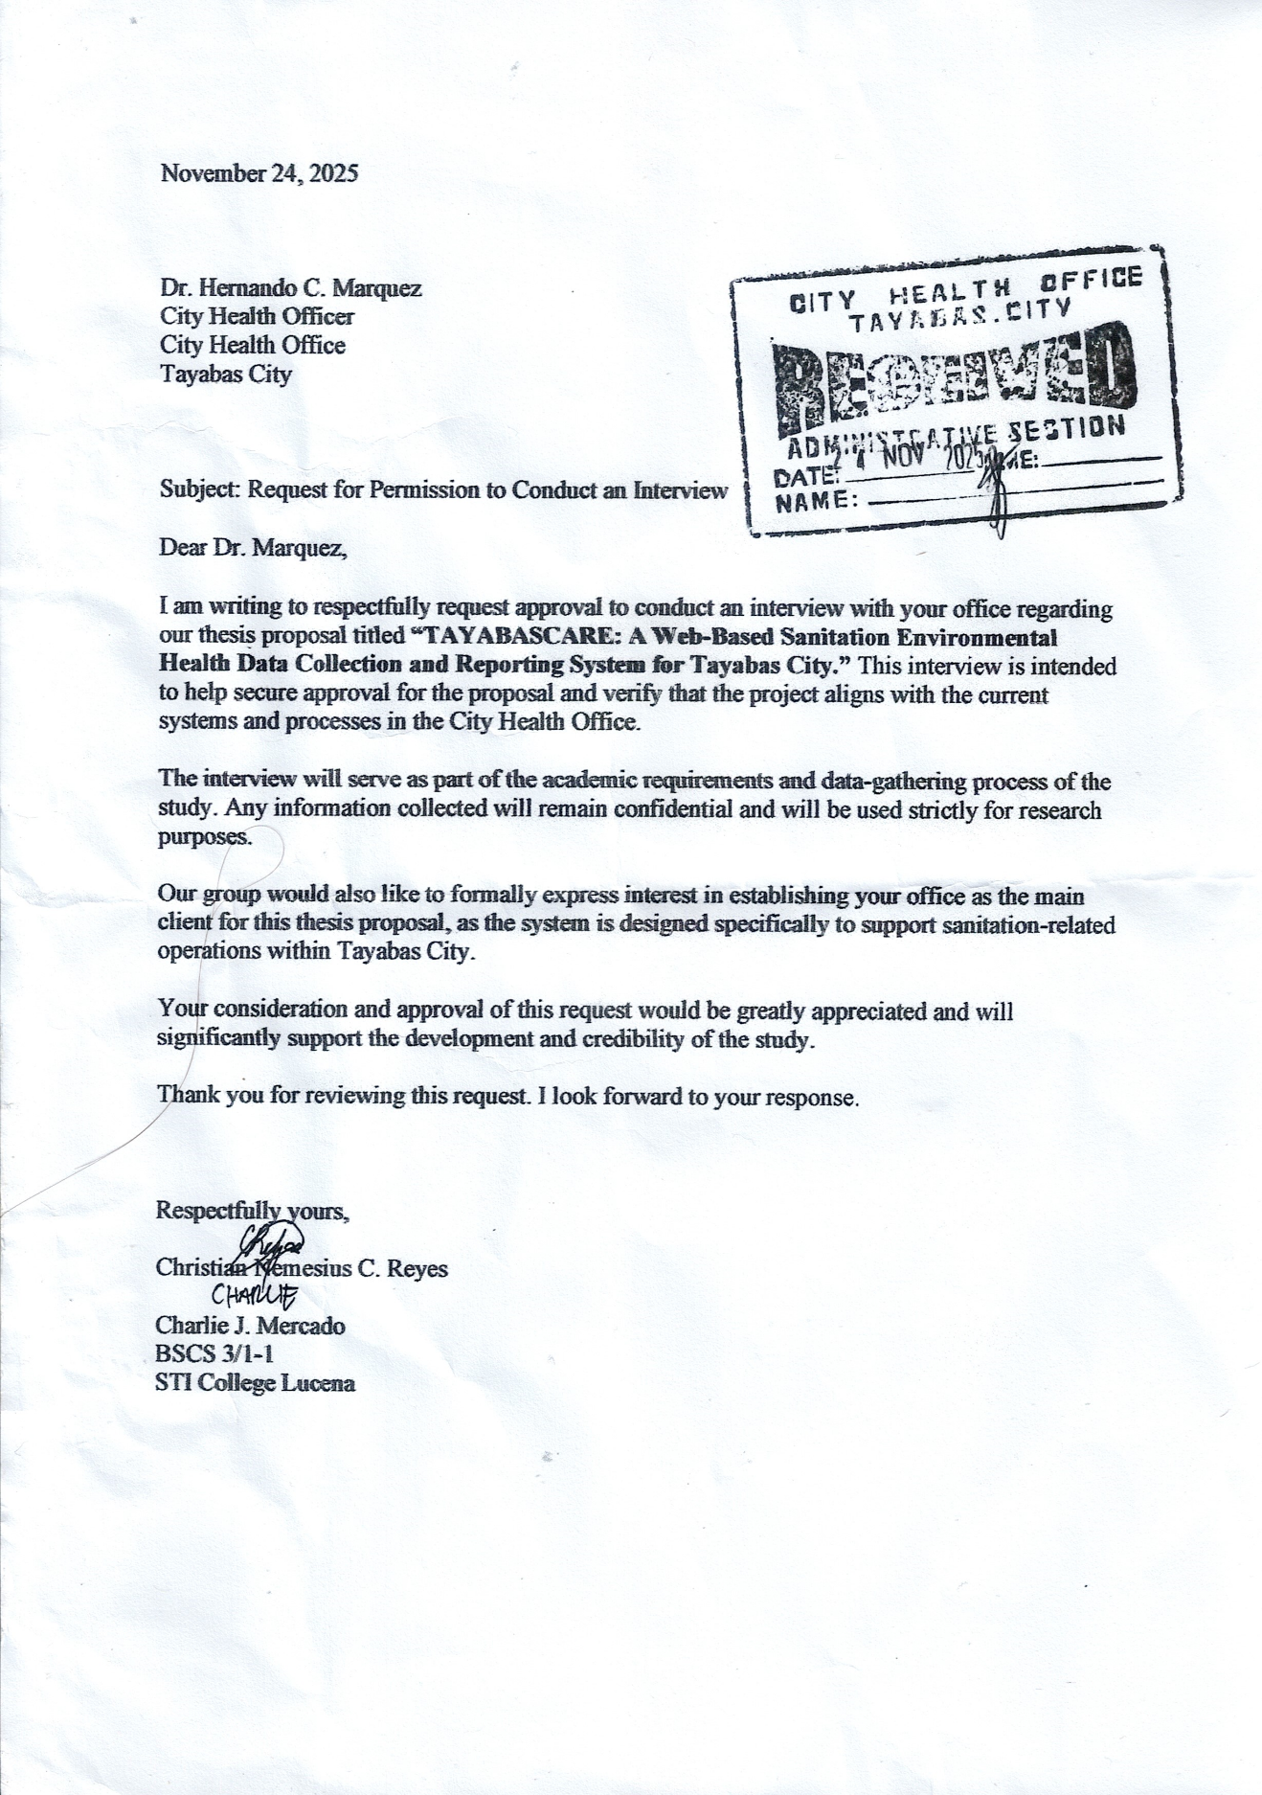

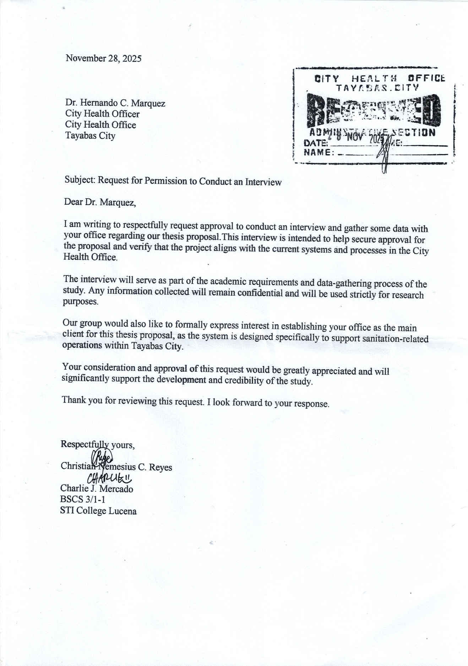

Transcript of Interviews

Interview of City Health Sanitation Officer
Name: Rommel D. Sate (Sanitation Inspector V)
Where: Tayabas City Old Municipal
Date: November 21 , 2025
Time: 3:00 PM
Interviewer: Christian Nemesius Reyes

(0:01) Christian Nemesius Reyes: Magmamanual na ano sulat sulat.

(0:03) Rommel D. Sate: Edi parang ganun yung tubig nyo?

(0:06) Christian Nemesius Reyes: Kung baga po pag mangayayari po nito faster yung sa munisipyo at sa baranggay.

(0:17) Rommel D. Sate: May sample kayo?

(0:18) Christian Nemesius Reyes: Wala nga po sample, proposal pa lang po kasi sya eh, hindi na po kami pinag ganon.

(0:26) Rommel D. Sate: Hindi, kasi kung proposal siya dapat meron na kayong sample kasi proposal yun eh.

(0:31) Christian Nemesius Reyes: Iba po kasi yung pinakang thesis namin talagang ano uhmm..

(0:35) Rommel D. Sate: Iba thesis nyo?

(0:36) Christian Nemesius: Iba po kasi yung sa CS pong thesis, capstone po kasi yung samin.

(0:43) Rommel D. Sate: Uhmm…

(0:41) Christian Nemesius: Aabutin po sya ng ano…

(0:47) Rommel D. Sate: Isang taon?

(0:48) Christian Nemesius Reyes: Two Years.

(0:49) Rommel D. Sate: Two Years?

(0:50) Christian Nemesius Reyes: Uhmm.. One and half years.

(0:52) Rommel D. Sate: Kung gusto mo ay more on one year lang.

(0:55) Christian Nemesius Reyes: One and a half po sana, tulad po ngayon first Sem, tapos develop yung isang buong taon hanggang chapter four tsaka yung final defense po namin.

(01:08) Rommel D. Sate: Anong year nyo na?

(01:09) Christian Nemesius Reyes: Third year po.

(01:11) Rommel D. Sate: Third year?

(01:13) Rommel D. Sate: So, next year kayo possible na?

(01:16) Christian Nemesius Reyes: Hindi po uhmm… next next years pa po.

(01:20) Rommel D. Sate: Hindi pa kayo gagawa?

(01:21) Rommel D Sate: Anong course nyo?

(01:23) Christian Nemesius Reyes: Computer Science po.

(1:25) Rommel D. Sate: Computer Science?

(1:28) Christian Nemesius Reyes: Opo.

(1:30) Christian Nemesius Reyes: First Sem palang po kami.

(01:31) Rommel D. Sate: Huh?

(01:32) Christian Nemesius Reyes: First Sem.. opo yung sa ano po.

(01:37) Christian Nemesius Reyes: Hindi, 2027 po ang ano namin.

(01:40) Rommel D. Sate: 2027 ang final defense nyo?

(01:43) Christian Nemesius Reyes: Ang final defense po… december po next year .

(01:46) Rommel D. Sate: Next year?

(01:48) Christian Nemesius Reyes: Opo december.

(01:49) Rommel D. Sate: Third year kayo ngayon next year Fourth year na?

(01:51) Christian Nemesius Reyes: Opo

(01:56) Rommel D. Sate: Hindi ko kasi masyadomg ma ano… hindi ko kasi gets yung unang ano… Wala naman problema samin, kumg ano yung kailangan nyong scope? Ah maglagay nalang kayo ng gagawin nyo uhmm… ano nga uhmm..

(02:20) Christian Nemesius Reyes: Gagawin po namin kayo na client.

(02:22) Rommel D. Sate: Client?

(02:25) Christian Nemesius Reyes: Kasi kayo po yung gagawan namin ng system.

(02:29) Rommel D. Sate: Kami ang gagawan nyo ng system? sige, kung gagawan ng system yun yung uhmm..

(02:35) Christian Nemesius Reyes: Ito po kasi yung pinaka ano nya… yung background of uhmm… yun po ay naka focus sa gumaca.

(03:55) Rommel D. Sate: Ito kasing ano ninyo.. scope ay uhmm… water source safety, toilet, household. Actually itong system nyo ang gagawin ay uhmmm..

(04:31) Chrslistian Nemesius Reyes: Kung ano po yung naisip nyo possible po kayang pumasok?

(04:36) Rommel D. Sate: Pwede naman.

(04:50) Rommel D. Sate: Ito kasi yung ano.. yan yung scope na nakalagay sa inyo, toilet yan so, household sanitation service, so mag a-add ka ng permission, water sources, disposal…submitted. Meron pa kaming GPS location kung saan ayan.. So, yun din yung scope ninyo halos same lang din… So meron pag nag submit ka….

(05:19) Christian Nemesius Reyes: Kung sa business po parang ganyan din po ang kalalabasan?

(05:23) Rommel D. Sate: Oo, pwede.

(05:32) Rommel D. Sate: Kasi kung ganon din… parang business din kasi meron na kami.

(05:39) Christian Nemesius Reyes: Application?

(05:40) Rommel D. Sate: Application sya.

(05:44) Christian Nemesius Reyes: Iaano na lang po namin sya kung…

(05:46) Rommel D. Sate: Same lang din yung mga.. kung ano man nakalagay sa ano… halos same lang din sa ano… sa description So, ang mangyayari… yung scope nila kasi yung ay online din at tsaka kung baga system… kasi sistema ng scope yun eh na para lang malaman yung baranggay nila. Ito naman naka focus nyo ay sa establishment.

(06:19) Christian Nemesius Reyes: Establishment? imbes na household po?

(06:23) Rommel D. Sate: Kung papayag adviser nyo.

(06:25) Christian Nemesius Reyes: Possible naman po kasi iisa lang naman din po ang iikotan ma iiba lang po.

(06:29) Rommel D. Sate: Oo, kasi yung household malaking scope… ang scope kasi kung baga kung tayabas kasi nakalagay gumaca.

(06:38) Christian Nemesius Reyes: Ano po kasi nila naka focus kung may problema po talaga.

(06:41) Rommel D. Sate: Oo, pero e-scope mo sya lahat kung sino sino uhmm. kukunin mo lahat kasi nasa scope diba?

(06:55) Christian Nemesius Reyes: Ano po naman yun yung Data Gathering next ano po panamin yun after pa po nitong proposal.

(07:03) Rommel D. Sate: Kaya nga after proposal nyo yung kasing… I mean yung thesis nyo na tatakbo.

(07:08) Christian Nemesius Reyes: Opo.

(07:09) Rommel D. Sate: Uhmm… mahanap yung problem mag household kayo?

(07:14) Christian Nemesius Reyes: Yun naman po talaga gagawin.

(07:15) Rommel D. Sate: Kaya nga… Uhmm.. yung problema para ma consolidate ito naman establishment pero same lang din yung waste disposal uhmm.. water accessible mga ganon pero ang gusto kung mangyari. Once na ito ay sa establishment pwede siya Uhmm… once ma improve yung main establishment uhmm.. contemplated na sanitary permit.

(07:52) Christian Nemesius Reyes: Kung baga po yung parang template nyo pong ano?

(07:55) Rommel D. Sate: Oo.

(07:56) Christian Nemesius Reyes: Kusa na pong magbago… siguro po ay kaya… kasi ang suggestion po nila lagyan po namin ng AI.

(08:05) Rommel D. Sate: AI? ba ilalagay?

(08:06) Christian Nemesius Reyes: Hindi ko pa po masyadong… parang dun nga po sa pag a-ano eh yung diba po QR code na ano pag pinicturan automatic na pupunta po dun sa file parang ganon po yung AI.

(08:23) Rommel D. Sate: Sino magbinigay ng QR code?

(08:25) Christian Nemesius Reyes: Hindi ko po kasi gets yung sinabi basta ang suggestion lang approval po talaga ng pupuntahan namin.

(08:41) Rommel D. Sate: Wala naman problema sakin.. pero iano nyo rin na yung scope nyo hindi na para magpaggawa ulet kami kasi meron na kame, pero kung sinasabi ko sa mga establishments pwede wala naman problema, tutulongan namin kayo sa mga datas.

Transcript of Interviews
Interview of City Health Sanitation Officer
Name: Rommel D. Sate (Sanitation Inspector V)
Where: Tayabas City Old Municipal
Date: November 28 , 2025
Time: 3:00 PM
Interviewer: Christian Nemesius Reyes

(0:01) Rommel D. Sate: Actually mga ganon, Kaso nga lang...

(0:22) Rommel D. Sate: Parang nabago yung uhh yung kanilang...

(0:34) Rommel D. Sate: Kung saan sila , parang ganon. Parang naka categorized.

(0:41) Rommel D. Sate: Tapos ay pwede na siyang.

(00:54) Christian Nemesius Reyes: Yung amin po kasi baranggay e.

(0:59) Rommel D. Sate: Oh yan, naka per baranggay siya.

(01:02) Christian Nemesius Reyes: Uhh sa establishment po?

(01:05) Rommel D. Sate: Ahh.

(01:09) Christian Nemesius Reyes: Yung amin kasi sir, household per baranggay, household po

(01:13) Christian Nemesius Reyes : Kung anong household yung hindi maganda sanitary, parang ganon po e

(01:22) Rommel D. Sate: Kasi kung sanitary, mga household...Meron na kami

(01:32) Christian Nemesius Reyes: Sir, kumbaga po yung sa mga business po?

(01:35) Rommel D. Sate: Yung nga sana, yung nga sana inyong capstone...

(01:41) Christian Nemesius Reyes: About sanitation po...Kaso yun nga po per household po...

(01:51) Rommel D. Sate: Kasi yun nga, meron na kami...Actually application downloadable siya.

(02:24) Christian Nemesius Reyes: Sir, pasok naman po, halimbawa po ay pag yung sa business?

(02:35) Rommel D. Sate: Ito oh, Sanitation Survey Mobile app. Survey ng household. Kung ano lang sa baranggay na ito.

(02:42) Christian Nemesius Reyes: Ahh yun po.

(02:51) Christian Nemesius Reyes: Parang ganyan nga din po yung kalalabasan nung amin kaso ay website po.

(02:55) Rommel D. Sate: Ahh...kung yung naman ano.

(03:02) Christian Nemesius Reyes: Establishment.

(03:05) Rommel D. Sate: Maganda naman siya, actually , hindi siya per household.
(03:12) Christian Nemesius Reyes: Sa buong Tayabas po?

(03:16) Christian Nemesius Reyes: Ahh sir, tanong ko lang po, hanggang kailan po baga'y mapapayagan kami doon.

(03:21) Rommel D. Sate: Mapapayagan kayo..?

(03:24) Christian Nemesius Reyes: Yun po yung idea niyo po na gagawin namin na...Instead na barangay , establishment na po.

(03:32) Rommel D. Sate: Mas ayos yan.

(03:35) Christian Nemesius Reyes: Kumbaga yung approval niyo po sir...Na pumapayag po kayo maging client po namin.

(03:40) Rommel D. Sate: Ah, Letter po muna. Mag letter po muna kayo ipapa receive natin. Itatanong natin.

(04:01) Christian Nemesius Reyes: Pwede naman po sa monday po? Sige po.

(04:05-07) Christian Nemesius Reyes: Salamat po.

Transcript of Interviews
Interview of City Health Sanitation Officer
Name: Rommel D. Sate (Sanitation Inspector V)
Where: Tayabas City Old Municipal
Date: November 24 , 2025
Time: 9:20 PM
Interviewer: Christian Nemesius Reyes

(0:01) Christian Nemesius Reyes: Good Morning po, So bale ang plano nga po namen yung pong sa stablisment nyo na lang po. Kumbaga yun na lang po ang gagawin namen.

(0:09) Rommel D. Sate: Ang mangyayari sabi ko nga yung ang data collection nyo ay establishment and yung magiging output ay yung paperless na workloading. Yung less na ang kumbaga for example pag encode mo gagawa ng system nakaderetsyo sya sanitary permit, kung anong establishment, kung anong data and pwede didiretsyo na sya sa sanitary printing tapos yung reporting nandun na yung monthly quarterly for printing na rin. Para mas easy yung and mas madali na yung process.

(1:17) Christian Nemesius Reyes: So ano tanong lang po gano po ba kadami ang establishment dito sa tayabas?

(1:23) Rommel D. Sate: Nasa 4,000.. Ilan nga establishment nten? Almost 3.. 3,000.

(1:46) Christian Nemesius Reyes: So yun lang po yung mareresolve nung system para mapabilis lang po yung process?

(1:52) Rommel D. Sate: Hindi siya actually para mapabilis ang process, yung process kasi ng business sanitary permit ay mabilis talaga kasi siya ay naka one stop siya. So ang mapapabilis nito ay ang system namen. Kasi ang system namen gagawin eencode namen tapos mag eencode kame for sanitary permit, tapos eencode namen for health card tapos igegenerate pa namen para meron kame for our consultations for our reports.

(2:27) Christian Nemesius Reyes: Bale madami pong encoding?

(2:30) Rommel D. Sate: Oo

(2:32) Christian Nemesius Reyes: Ang mangyayari po isang encode lang po?

(2:35) Rommel D. Sate: Oo

(2:36) Christian Nemesius Reyes: Ok po.

(2:37) Rommel D. Sate: Ganun ang gusto kong mangyari.

(2:40) Christian Nemesius Reyes: Ah ok po. Yun nga po pinaka proposal nung system ung susundin kung ano po suggested nyo kung ok lang po sa inyo na kayo ang gawin po nameng client.

(2:55) Rommel D. Sate: Oo naman.

(2:57) Christian Nemesius Reyes: Bale yun lang naman po. Ano po pangalan nyo sir? Para ilalagay namen sa ano.

(3:15) Rommel D. Sate: Kung kaya naman yang gawin walang problema.

(3:55) Christian Nemesius Reyes: Paano po ba kayo macocontact? Direct na lang po ba kami dito or san po kayo pwedeng macontact?

(4:01) Rommel D. Sate: Pano? Bakit kailangan?

(4:03) Christian Nemesius Reyes: Halimbawa ay dagdag katanungan po mga data gathering po. Diretsyo na lang po ba dito?

(4:13) Rommel D. Sate: Oo.

(4:14) Christian Nemesius Reyes: Sige po sir Thank you po sir.
Transcript of Interviews
Interview of City Health Sanitation Officer
Name: Zaldy Ramos (Sanitation Inspector V)
Where: Tayabas City Annex Building
Date: November 28 , 2025
Time: 10:50 AM
Interviewer: Christian Nemesius Reyes

(0:03) Zaldy Ramos: Yung lang sa may mga poultries yung mga hindi nasunod...Yung hindi nasunod

(0:07) Christian Nemesius Reyes: Ahhh, yung halimbawa po ay...Binigyan niyo po ng bawal na ganto

(0:11) Zaldy Ramos: Findings. Mga recomendation, findings pala muna pag hindi sumunod doon...Mag rerecommend kami ng for closure...

(0:22) Zaldy Ramos: Yung pinaka challenge samin...

(0:26) Christian Nemesius Reyes: Ahhh so ano po, gaano po ba kadami mga establishment dito sa sinabi ni

(0:30) Zaldy Ramos: Aba'y mga nasa 3,000

(0:32) Christian Nemesius Reyes: Ahhh mga 3,000 po
(0:34) Zaldy Ramos: Mga 3,000 more or less

(0:37) Christian Nemesius Reyes: Ahhh so yun nga pong sinabi niyong sa pag eencode po...Gaano po katagal bago matapos yung encoding?

(0:46) Zaldy Ramos: Hindi ang ano naman kada pasok ng kliyente encode tapos gawan namin ng health card which is nandoon sa new city hall

(01:06) Christian Nemesius Reyes: Bale ilang user po makakagamit nung system?

(01:13) Christian Nemesius Reyes: Department po?

(01:15) Zaldy Ramos: Department? Wala , kami lang , Sanitation lang kami lang.

(01:19) Christian Nemesius Reyes: Diba part din po kayo nang health? Kumbaga ay isang section na po? Health? Sanitary?

(01:21) Zaldy Ramos: Iba iba pa.

(01:24) Zaldy Ramos: Mga data entry hehe...Challenge yun e.

(01:26) Christian Nemesius Reyes: Pero part po ng Sanitation?

(01:29) Zaldy Ramos: Hindi, sa amin na yun.

(01:34) Zaldy Ramos: Isang program lang Sanitation e.

(01:38) Christian Nemesius Reyes: Tapos sila po?
(01:41) Zaldy Ramos: Madaming programs, isang part lang ay sanitation.

(01:44) Christian Nemesius Reyes: Sa health po?

(01:47) Zaldy Ramos: Iba't iba din.

(01:51) Christian Nemesius Reyes: Ahh bale yung sa establishment po?

(01:58) Zaldy Ramos: Establishment sa amin yun.

(02:05) Christian Nemesius Reyes: Hindi na po part yung health? Sanitation lang po?

(02:09) Zaldy Ramos: Hmmm...Ano bang sinasabi mong health ? Parte na rin yun ng Sanitation parte ng Health yun.

(02:14) Christian Nemesius Reyes: Yung po bang health card po, wala po sa establishment yun?

(02:16) Zaldy Ramos: Sa establishment yun...

(02:19) Christian Nemesius Reyes: Yun po sir bale pag edi bale dalawa po? Sa amin lang Sanitation lang.

(02:21) Christian Nemesius Reyes: Tapos sainyo din po makukuha yung card?

(02:25) Zaldy Ramos: Yung sanitary permit saka ieencode.

(02:29) Christian Nemesius Reyes: Ahh ok po bale kayo lang po?

(02:35) Zaldy Ramos: Oo, wala na, kapag nagpapacheck up lang.

(02:42) Christian Nemesius Reyes: Hinihingian pa rin po ba ng X-RAY?

(02:58) Zaldy Ramos: Yun, Yearly.

(03:02) Christian Nemesius Reyes: Yearly po?

(03:10) Zaldy Ramos: Yearly tsaka yung ating...Every 6 months yung aming x-ray yung aming stool.

(03:14) Zaldy Ramos: Sa amin naman, yung sa aming system ano lang e dropdown lang. Ang gusto namin mangyari naka table naka pie graph.

(03:18) Christian Nemesius Reyes: Ahhh kumbaga po wala kayong mismong database?

(03:24) Zaldy Ramos: Pero yung isa naming ano...Nag gawa ako nung database galing DOH...Ipapakita ko sayo yung sa aming toilet sanitation.

(03:31) Christian Nemesius Reyes: Yung ano po sa AI po ano pong pwedeng kumbaga po yung mag bebenefit sainyo.

(03:54) Zaldy Ramos: AI...Yung madali namin madedetect kung sino yung wala o kung sino yung meron.

(04:01) Christian Nemesius Reyes: Kasi po yung nasa isip ko diba po nagsusuri po kayo nang mga toilet.

(04:09) Zaldy Ramos: Oo, household naman yun kapag ka ganon.
(04:14) Christian Nemesius Reyes: Yung sa establishment po? Sinusuri rin po ba toilet?

(04:19) Zaldy Ramos: Yep isang part...isang criteria.

(04:28) Zaldy Ramos: Halimbawa kunware madumi.

(04:35) Zaldy Ramos: Hindi, may findings kasi kami nun.

(04:42) Zaldy Ramos: Yung nasa idea po...

(04:51) Zaldy Ramos: May checklist yun e.

(05:00) Christian Nemesius Reyes: Yung nasa idea ko po kasi diba po pipicturan yung establishment yung ano na po sa mismong toilet na po...Tapos idedetect na po ni AI kung pasok po sa criteria ninyo...Pag may lalabas na hindi...

(05:04) Zaldy Ramos: Mag rerecommend kami.

(05:09) Christian Nemesius Reyes: Yung AI na po magrereject na kulang sa ganto ganiyan pero yung ni rerecommend niyo pong yung sa hindi po updated.

(05:13) Zaldy Ramos: Ahhh yung sa yearly niya? Yung frequency.

(05:18) Christian Nemesius Reyes: Kumbaga po yun po yung nasa isip niyo po yung ipapasok ng AI.

(05:22) Zaldy Ramos: Oo yun, Kung ano...Depende sa AI.

(05:28) Christian Nemesius Reyes: Madami naman po kasing klase...Kumbaga po yung flow niya.

(05:31) Zaldy Ramos: Nung aming sanitary permit?

(05:34) Christian Nemesius Reyes: Opo, na paro po ma i ano ng AI.

(05:38) Zaldy Ramos: Yung sa AI yung amin ay may inspection.

(05:43) Christian Nemesius Reyes: Diba po pag nag iinspect ay may papel po? Tapos sainyo na po ipapasa yung papel?

(05:48) Zaldy Ramos: Hindi, kami na nagsusulat sa papel.

(05:55) Christian Nemesius Reyes: After po nun?

(06:03) Zaldy Ramos: Kung ano nakitang findings, yun ang isusulat mag rerecommend kami.

(06:09) Christian Nemesius Reyes: Hindi niyo na po inaano sa docu?

(06:12) Zaldy Ramos: Sa hardcopy na.

(06:19) Christian Nemesius Reyes: Edi nasa hardcopy edi tambak po? Yung papel po tambak na? May nawawala po?

(06:24) Zaldy Ramos: May nawawala din .

(06:29) Christian Nemesius Reyes: Pag po may nawawalan?
(06:31) Zaldy Ramos: Naka file kasi yun, yun ang challenges...Nawawala.

(06:37) Zaldy Ramos: Pag may nawawala, Accomplishment namin yun, Vinavalidate namin. Every after year.

(06:49) Christian Nemesius Reyes: Sa pag eencode po wala naman pong problema?

(07:03) Zaldy Ramos: Edi kung ano lang pumasok yun lang ieencode.

(07:09) Zaldy Ramos: Yung lang nasa system namin. Nandon yung Pangalan, X-RAY, Yes or No, Male or Female, Pangalan ng establishment.

(07:15) Zaldy Ramos: I-add mo ako isesend ko sa iyo. Althought nandoon rin naman sa excel file namin.

(07:23) Zaldy Ramos: Iba pa yung stool at sanitation ah, isang part lang yun. Sanitary permit, tulad ng water sanitation dun lang.

(07:37) Christian Nemesius Reyes: Kasi po hindi namin pwede isama sa AI yung water sanitation, kasi po kailangan na po ng hardware diba po yun.

(07:48) Christian Nemesius Reyes: Parang po paano niyo po tinetest yung water.

(08:02) Zaldy Ramos: Ahhh ano lang yung result lang .

(08:10) Christian Nemesius Reyes: Bawal naman pong picturan tapos AI na yung bahala. Meron naman pong tubig ay contaminated naman.

(08:16) Zaldy Ramos: Ahh may testing yun, Laboratory, yung sa amin lang results.
(08:19) Christian Nemesius Reyes: Ahh hindi po kayo ang nag tetest?

(08:21) Zaldy Ramos: Hindi.

(08:26) Zaldy Ramos: Results kung pass or fail.

(08:34) Christian Nemesius Reyes: Yung AI po sa toilet lang mangyayare.

(08:46) Zaldy Ramos: Ang problema namin ay kung sino may toilet o wala. May masterlist din lang yun.

(09:05) Zaldy Ramos: Kase walang picture sa amin sa household. Sa establishment lang.

(09:12) Christian Nemesius Reyes: Ang proposal po namin nung una ay sa household. Sabi po ni Sir Rommel, meron na daw po kayo nun .

(09:22) Zaldy Ramos: May pinakita ba sainyong database?

(09:36) Christian Nemesius Reyes: Opo, yung pinakita po sa aming scope

(09:39) Zaldy Ramos: Anong scope lang ba?

(09:43) Christian Nemesius Reyes: Yung sa sanitation po sa household kung sino po .

(09:47) Zaldy Ramos: Household...Kung sino walang toilet?

(09:54) Christian Nemesius Reyes: I aano po nang city.

(09:59) Zaldy Ramos: Yung ang aking proposal...Ililist kung sinong wala.

(10:03) Christian Nemesius Reyes: Bale yun po kaso sabi po ni sir Rommel meron na daw po, may pinakita po kasing application e.

(10:11) Zaldy Ramos: May application na yun, Although may application na rin akin galing DOH.

(10:15) Christian Nemesius Reyes: Kaya kesa magpagawa po sa amin ay same lang naman daw po, masasayang lang.

(10:18) Zaldy Ramos: Which is walang gumagawa...

(10:21) Zaldy Ramos: Yung sa IT, kung sino ang tao may data entry pa, yung sa akin may data entry na.

(10:24) Christian Nemesius Reyes: Kaya ang nangyare po ang kinalabasan yung suggestion...

(10:27) Zaldy Ramos: Sanitary permit.

(11:01) Christian Nemesius Reyes: Imbis na madami pong ieencode yun po.

(11:09) Zaldy Ramos: Hindi e, ganon din ieencode, yung sa kanyan ieencode pa, yung sa akin i update nalang, marami na nasa 2,000 household na encode ko, i uupdate nalang.

(11:16) Christian Nemesius Reyes: Pag yung establishment ay halimbawa po , close na, ano pong mangyayare sa data?

(11:18) Zaldy Ramos: Ahh ay wala na.
(11:25) Zaldy Ramos: Kung close na hindi na kami mag bibigay ng sanitary permit, Next year mababawasan yung amin masterlist.

(11:27) Christian Nemesius Reyes: Hindi niyo po dinedelete?

(11:29) Zaldy Ramos: Hindi.

(11:34) Zaldy Ramos: Mag aaply yung closure ng treasury.

(11:37) Zaldy Ramos: Kapag po nag apply ng closure? Wala kaming kontrol, Kung sino lang nag apply sa amin yun lang mabibigyan namin ng sanitary permit.

(11:39) Christian Nemesius Reyes: Talagang hindi na po mawawala sainyo yung data?

(11:44) Zaldy Ramos: Hindi mawawala.

(11:57) Zaldy Ramos: Yung data mismo, lahat ng data nasa new city hall.

(12:04) Zaldy Ramos: Yun lang nadoon, pwede kong maisend sayo.

(12:12) Christian Nemesius Reyes: Pinaka pronblem po ay yung pag encode, yung update ?

(12:16) Zaldy Ramos: At monitoring.

(12:18) Christian Nemesius Reyes: Paano pong monitoring?

(12:21) Zaldy Ramos: Edi yung ano namin pag iinspection, yun lang ieencode namin.

(12:26) Christian Nemesius Reyes: Ahh mula una po yung pag eencode?

(12:29) Zaldy Ramos: Kung anong ininspect namin nung monitoring.

(12:45) Christian Nemesius Reyes: Pag update po? Another encode po lahat .

(13:01) Zaldy Ramos: Kung ano yung nainspect namin.

(13:11) Christian Nemesius Reyes: Ang mangyayari po kasi nung system web based po e online po siya

(13:17) Zaldy Ramos: May search engine? Print outcome?

(13:31) Christian Nemesius Reyes: Yung po ang suggestion ni sir automated na yung mga inencode pong data information po na collect niyo sa owner ng establishment.

(14:01) Christian Nemesius Reyes: Diretso na po sa template.

(14:05) Zaldy Ramos: Magddropdown nlng ng select .

(14:09) Christian Nemesius Reyes: Opo pabibilisin po.

(14:17) Christian Nemesius Reyes: Pero may kaunting encode din po.

(14:23) Zaldy Ramos: Meron na kaming cinocopy doon.

(14:28) Christian Nemesius Reyes: Edi mangyayare po update nalang po? Edi may filtering po para mpadali po yung search?
(14:35) Christian Nemesius Reyes: Yung sainyo po ba wala?

(14:39) Zaldy Ramos: Wala.

(14:40) Christian Nemesius Reyes: Naka alphabetical naman po?

(14:42) Zaldy Ramos: Hindi.

(14:56) Christian Nemesius Reyes: Jumbled po? Ahh edi ang hirap po.

(15:00) Zaldy Ramos: Kung ano lang pumunta yun lang number. Ang number naman...

(15:10) Christian Nemesius Reyes: Edi sa number po mag babased?

(15:17) Zaldy Ramos: Pero di alphabetical.

(15:23) Christian Nemesius Reyes: Pero mas maganda pa din po kung siguro alphabetical pangalan at isang part nalang po yung number.

(15:29) Zaldy Ramos: Kami na mag eencode

(15:35) Zaldy Ramos: Sesearch mo nlng panagalan, then lalabas pangalan

(15:40) Christian Nemesius Reyes: Naka alphabetical na po siya

(15:54) Zaldy Ramos: Kung ano status niya lalabas lahat diba?

(16:02) Christian Nemesius Reyes: Ano po yung mga nararanasan niyong problema sa tracking

(16:07) Zaldy Ramos: Tracking ng establishment?

(16:11) Zaldy Ramos: Edi yung mga walang mga comply

(16:18) Christian Nemesius Reyes: Ganon din po sa pag monitor?

(16:24) Zaldy Ramos: Kung yung findings namin hindi nasunod, babalikan namin sa sunod, recommend namin kung ano man recommendation...Every inspection may findings may checklist e

(16:29) Christian Nemesius Reyes: May checklist din po kayo sa violation?

(16:34) Zaldy Ramos: Meron mga demerits

(16:45) Christian Nemesius Reyes: Yun po yung na momonitor niyo?

(16:56) Zaldy Ramos: Kung meron

(17:04) Christian Nemesius Reyes: Gaano po kaya kadalasang bumalik sa aestablishment?

(17:11) Zaldy Ramos: May frequency e mmay 3 months may weekly may monthly

(17:16) Christian Nemesius Reyes: Pero pag update po nang mga permit?

(17:28) Zaldy Ramos: Yearly ang sanitary permit.

(17:37) Christian Nemesius Reyes: May sinabi po kasi sir na monthly at quarterly

(17:45) Zaldy Ramos: Ahhh ano yun sa water yun. Pinapatest yun

(17:49) Christian Nemesius Reyes: Bale magiging specific po kasi yung gagawin namin kasi kailangan po ng hardware yun.

(17:57) Zaldy Ramos: Results lang basis namin, kung ano lang lumabas sa result yun lang ang amin ieencode.

(18:01) Zaldy Ramos: Which is mahirap pag ganon sa water sanitation

(18:10) Christian Nemesius Reyes: Opo ang mangyayare po kasi niyan magiging malawak po

(18:17) Zaldy Ramos: Although my nasa 60 lang yun 60 piraso lang

(18:26) Christian Nemesius Reyes: Ang sabi daw po ay kailangan hardware...Yung sa garbage po kaya? Paano po inspect nun?

(18:35) Zaldy Ramos: Kasama yun sa findings sa establishment.

(18:40) Zaldy Ramos: Edi kung ano meron, edi kung wala, meron demerits.

(18:47) Christian Nemesius Reyes: May time po kayong hindi niyo namomonitor yung establishment?

(19:03) Zaldy Ramos: Meron kapag walang service

(19:12) Zaldy Ramos: Though kahit merong criteria, pwede isang highrisk low medium, low medium wala gaano violation

(19:17) Zaldy Ramos: Mga sari sari store low risk, mga poultries high risk yan.

(19:21) Christian Nemesius Reyes: May naduduplicate din po bang na eencode

(19:28) Zaldy Ramos: Possible yun, pwede.

(19:37) Christian Nemesius Reyes: Nangyare na po?

(19:49) Zaldy Ramos: Hindi pa naman.

(20:02) Christian Nemesius Reyes: Pero naka centralized po yung system niyo po ano?

(20:11) Zaldy Ramos: Sa amin lang.

(20:18) Christian Nemesius Reyes: So paano po kayo nag uupdate sa mga establishment? Tungkol po sa status nung application? Pinupuntahan niyo po?

(20:23) Zaldy Ramos: Sa amin inspection lang

(20:30) Christian Nemesius Reyes: Nag aantay rin po ang establishment ng results?

(20:42) Zaldy Ramos: During the time

(21:02) Christian Nemesius Reyes: Alam na po nila?

(21:12) Zaldy Ramos: May checklist yun e.

(21:19) Christian Nemesius Reyes: Pag submit po ng reports may deadline po?

(21:29) Zaldy Ramos: Monthly ang aming reporting, Sa amin lang

(21:36) Zaldy Ramos: Yung concern niyo ngayon ay establishment? Marami kasing scope ang sanitation

(21:42) Christian Nemesius Reyes: Nadedelay po ba ang pag gather niyo ng data?

(21:48) Zaldy Ramos: Hindi naman, dirediretso na

(22:05) Christian Nemesius Reyes: May nasasayang po ba sa pag eencode niyo sa mga information.

(22:12) Zaldy Ramos: Pag hindi lang complete details ay nasasayang.

(22:23) Zaldy Ramos: Na print na namin pero wala pa perma doctor, may perma kasi kami ng sanitary permit, sanitary inspector.

(22:34) Zaldy Ramos: Yun ang magiging problema niyo sa system, diba generated?

(22:45) Zaldy Ramos: Masterlist, after nito doon generate na din ang sanitary permit

(23:06) Christian Nemesius Reyes: Diretso na po sa template?

(23:10) Zaldy Ramos: Perma kami muna and then perma doctor
(23:18) Christian Nemesius Reyes: Ilan po ba naperma doon?

(23:26) Zaldy Ramos: Kami at si doctor, kani kaniyang area.

(23:31) Christian Nemesius Reyes: Bale po lima po yung pipirma?

(23:49) Zaldy Ramos: Per area yun. Cluster ng lugar.

(24:01) Zaldy Ramos: Pero iba't ibang pirma

(24:10) Christian Nemesius Reyes: Possible po kaya na automate po pirma niyo?

(24:15) Zaldy Ramos: Signature? Hindi.

(24:23) Christian Nemesius Reyes: Mangyayare po pala pagka print nung template, tsaka lang pipirma

(24:41) Zaldy Ramos: Yun pirma muna namin.

(25:06) Christian Nemesius Reyes: Papakita po yung template, pagka encode po iallagay ang pangalan ng owner ang problema po pagka printout wala pong pirma niyo

(25:53) Zaldy Ramos: Wala pa, tsaka palang kami pipirma.

(26:01) Christian Nemesius Reyes: Hindi naman po nahihirapan mag generate ng reports?

(26:19) Zaldy Ramos: Edi pag sira printer at computer, yun lang. Ngayon ay dadalawa lang gumagana.
(26:47) Christian Nemesius Reyes: Kapag mag cocompile po ng data statical reports nahihirapan po kayo?

(27:04) Zaldy Ramos: Retrieving? Medyo. Every folder kasi yun e.

(27:11) Christian Nemesius Reyes: Kumabaga nasa table po

(27:15) Zaldy Ramos: Ang ano namin jan yung storage

(27:19) Christian Nemesius Reyes: Sa database po?

(27:26) Zaldy Ramos: Pwedeng yung mismong CPU na which is risky sa virus.

(27:31) Zaldy Ramos: So dapat po may backup.

(27:35) Zaldy Ramos: Sa personal computer.

(27:39) Zaldy Ramos: Nangyare na po bang na late kayo ng pag submit ng reports?

(27:58) Zaldy Ramos: Kapag hindi naka tally lahat.

(28:14) Christian Nemesius Reyes: Yung sa picture naman po nahihirapan po kayo makita overall kumbaga lahatan po.

(28:27) Zaldy Ramos: Oo pag hindi namin nadodownload o upload pala.

(28:45) Zaldy Ramos: Every picture i upload namin per establishment.

(29:00) Christian Nemesius Reyes: Website lang po talaga kami namin kayang gawin.

(29:09) Christian Nemesius Reyes: Kaso po yung web magbabased sa internet

(29:14) Zaldy Ramos: Di pwedeng offline?

(29:25) Zaldy Ramos: De pwede namang offline lng tapos pagka meron nang internet automatic na yun.

(29:35) Christian Nemesius Reyes: Yun po ang aanuhin namin kung possible.

(29:55) Zaldy Ramos: Yun ang sistema namin dito, hindi lahat ng office may internet. Meron internet kaso sa cellphone lang.

(30:01) Christian Nemesius Reyes: Pag sa picture po diretso na din po sa information?

(30:10) Zaldy Ramos: Oo dapat which is wala kami nun.

(30:25) Christian Nemesius Reyes: So mangyayare pupunta po si inspector sa website iuupload yung picture.

(30:46) Zaldy Ramos: Oo.

(30:48) Christian Nemesius Reyes: Yung X-ray po yearly po ano?

(30:56) Zaldy Ramos: Every 6 months.

(31:08) Zaldy Ramos: Compliance di kompleto.

(31:13) Christian Nemesius Reyes: Meron pong hindi nag proprovide ng complete info po ano?

(31:18) Zaldy Ramos: Di may application yun.

(31:28) Christian Nemesius Reyes: Doon po sila unang nag cocomply?

(31:37) Zaldy Ramos: Oo.

(31:42) Christian Nemesius Reyes: Yung pagpasa po sainyo paper po?

(31:57) Zaldy Ramos: Hardcopy.

(33:02) Zaldy Ramos: X-Ray sa lahat ng establishment.

(33:15) Christian Nemesius Reyes: Sa inyo lang po yun binibigay?

(33:27) Zaldy Ramos: Sa amin lang.

(33:41) Christian Nemesius Reyes: Sa establishment po nag bebenta ng pagkain?

(34:02) Christian Nemesius Reyes: Sa hardware po hindi na kailangan ng stool?

(34:16) Zaldy Ramos: Pero malalaman mo yun sa system.

(34:34) Christian Nemesius Reyes: Pag ineencode niyo na po dropbox kung ano pong category?

(35:01) Zaldy Ramos: Ahh meron naka categorized.

(35:17) Christian Nemesius Reyes: Ang mangyayari po is kung ipapa approve po namin sainyo yung design. Kung approved po sainyo.

(35:32) Christian Nemesius Reyes: Ang ano po namin yung pinaka problem niyo.

(35:52) Zaldy Ramos: Doon ka nalang mag babased.

(36:06) Christian Nemesius Reyes: Kumbaga po makikita ko po mga problem po?

(36:09) Zaldy Ramos: Yung sinabi ko idagdag mo nlng doon, i visualize mo na catergory column na name per category, remarks

(36:14) Zaldy Ramos: Diba sa excel naman pwede ka mag add?

(36:27) Christian Nemesius Reyes: Bale matatanggal na din po category niyo.

(36:32) Zaldy Ramos: Maraming category merong others.

(36:36) Christian Nemesius Reyes: Paano pong others?

(36:39) Zaldy Ramos: Pag wala doon sa iba .

(36:45) Christian Nemesius Reyes: Pag wala po sa pamimilian.

(36:51) Zaldy Ramos: Food retail, food surveys...

(37:04) Zaldy Ramos: Fastfood, junkfood.

(37:06) Christian Nemesius Reyes: So ang pinaka problem lang po talaga is yung pag eenccode na durong tagal.

(37:15) Zaldy Ramos: Kapag na kompleto mo na yung last year, hindi ka na mamomroblema doon.

(37:19) Christian Nemesius Reyes: Ahh kumbaga hindi na po na uupdate taon taon?

(37:23) Zaldy Ramos: Taon taon kung may may bago lang o mayy iuupdate.

(37:29) Christian Nemesius Reyes: Pero ang nangyayari po sainyo kahit nandoon na po ineencode niyo pa po.

(37:46) Zaldy Ramos: Ano pa rin yun nag fifile up mga file paulit ulit.

(38:12) Christian Nemesius Reyes: So sir yun lang po. Salamat po.

Transcript Of Interview
Interview of City Health Sanitation Officer
Name: Rommel D. Sate (Sanitation Inspector V)
Where: Tayabas City Old Municipal
Date: October 22, 2026
Time: 3:15 PM
Interviewer: Christian Nemesius Reyes

(00:00) Christian Nemesius Reyes: So bale sir nandito po yung sa sanitary record po.

(00:15) Rommel Sate: Wait, diba mag rerecord ka? Video ba?

(00:30) Christian Nemesius Reyes: Hindi po bale audio record lang po.

(00:42) Christian Nemesius Reyes: For transcript purposes lang po.

(01:00) Christian Nemesius Reyes: Bale ito po sir yung sa establishment po kung ano pong category.

(01:24) Christian Nemesius Reyes: Bale ang gagawin po ilalagay pa po namin yung mismong full name po ng business.

(01:30) Christian Nemesius Reyes: Nilagyan na rin po namin ng building no.

(01:31) Rommel Sate: Okay…

(01:35) Christian Nemesius Reyes: Automatic po yung sa personnel, yan lang po ang lalabas.

(01:45) Christian Nemesius Reyes: Sa result po sir, pwede pong to follow siya or pag ano po ay required na?

(02:01) Rommel Sate: To follow?

(02:12) Christian Nemesius Reyes: Such as x-ray po at stool.

(02:19)Rommel Sate: Wala ba kayo nung pag-uuploadan?

(02:25) Christian Nemesius Reyes: Ahh, upload din po ba dapat?

(02:34) Rommel Sate: Oo.

(02:39) Rommel Sate: Pero yun rin naman ay encoding din, diba?

(02:48)Rommel Sate: Encode na lang. Kasi physical naman yung ibibigay sa amin eh.

(03:00) Christian Nemesius Reyes: So bale ang mangyayari po ay che-check na lang kung nakapagbigay na po?

(03:19) Rommel Sate: May comments ba 'yan or kaya remarks?

(03:45) Christian Nemesius Reyes: Opo, meron po. May remarks po. Also sir, required po yung x-ray sa mismong owner?

(04:08)Rommel Sate: Nope, lahat-lahat…

(05:15) Christian Nemesius Reyes: Personnel din po?

(05:25) Rommel Sate: Oo, sige…

(05:36)Christian Nemesius Reyes: Ito po yung nagawa naming sanitary permit…

(06:00) Christian Nemesius Reyes: Tama po ba si Ma'am Olive po yung napirma?

(06:19) Rommel Sate: Hindi, lahat kami.

(06:30)Christian Nemesius Reyes: Kumbaga po, rumble?

(06:35) Rommel Sate: Oo.

(07:41)Rommel Sate: Kasi pipili na lang ng pangalan and dapat wala siyang signature…

(07:15) Christian Nemesius Reyes: Okay po, babaguhin na lang po.

(07:30) Rommel Sate: Oo, diba kinuha mo mga pangalan namin.

(07:45) Christian Nemesius Reyes: Opo, kaso po ang nakuha ko lang pong format nito ay yung kay Ma'am Olive…

(08:00) Rommel Sate: Ahh, pero hiningi mo pa rin mga pangalan namin?

(08:11) Christian Nemesius Reyes: Opo, naka-registered naman po 'yan.

(08:19) Rommel Sate: Okay…

(08:23) Christian Nemesius Reyes: Tapos dito po sa view, ang mae-edit lang po ay yung sa personnel.

(09:40) Christian Nemesius Reyes: Diba po yearly naman po mababago ang personnel? Kung halimbawa po ay may umalis, nagbawas po ang establishment. Pwede pong magbawas diyan.

(10:15) Christian Nemesius Reyes: Aayusin ko pa po at yun po yung suggestion sa amin.

(10:32) Christian Nemesius Reyes: Ang mangyayari po pala dito, kung sino po yung nag-input ay sa kanya pong establishment 'yun?

(10:49) Rommel Sate: Ahhh, hindi… Ang gawin niyo na lang ay basta whole Tayabas, tapos kung sino yung nag-input ay makikita lamang.

(11:03) Christian Nemesius Reyes: Makikita po lahat ng inspector?

(11:11) Rommel Sate: Oo, kung sino lang yung nag-encode.

(11:22) Christian Nemesius Reyes: Paano po yung sa inspection?

(11:45) Rommel Sate: Area by area kami eh.

(11:50) Christian Nemesius Reyes: Eh di ang mangyayari po doon, si admin na lang po yung mag-a-assign?

(12:03) Rommel Sate: Pwede nang by inspector.

(12:14) Christian Nemesius Reyes: Ang nangyari po kasi dito ay kung sino po yung nag-inspect, sa kanya na po yung establishment.

(12:27) Rommel Sate: Oo, kasi diba binigay na namin yung per area namin.

(12:40) Rommel Sate: Pero nababago 'yun, sir? Or hindi naman?

(13:01)Rommel Sate: Sa ngayon hindi, medyo matagal ang reshuffle ng area namin.

(13:19) Christian Nemesius Reyes: Ang gagawin na lang po namin, sir, ay si admin na lang ang mag-a-assign.

(13:35) Rommel Sate: Okay, pwede.

(13:40) Christian Nemesius Reyes: Kumbaga, ano po siya, add schedule na yung date is i-inspect yung establishment po.

(13:57) Christian Nemesius Reyes: Tapos sa pag-inspect naman po, ganito po itsura po.

(14:05) Christian Nemesius Reyes: Diba po, may fina-fill up pa po kayong paper? Dito na lang din po i-upload katibayan po na na-inspect niyo na po. Lalabas po dito.

(14:14)Rommel Sate: Okay, sige…

(14:21) Christian Nemesius Reyes: Dito rin po, sir, yung sinabi niyo kung ilang days po bago magbigay ng compliance. Tapos dito rin po makikita yung mga history po nung establishment.

(14:35) Christian Nemesius Reyes: Also, sir, ito pong cadaver, ano po kaya 'yan?

(14:41) Rommel Sate: Transfer ng katawan 'yan.

(14:52) Christian Nemesius Reyes: Ito po kayang exhumation?

(15:00) Rommel Sate: Pagbubukas ng nitso. Ang exhumation kasi is bubuksan mo yung nitso, na it either may titingnan kayo o may ililibing doon ulit or itatransfer mo yung skeletal. Kaya merong skeletal transfer.

(15:20) Christian Nemesius Reyes: Paglilipat po ng nitso ang exhumation. Ang cadaver naman po ay…

(15:30) Rommel Sate: Paglilipat ng patay. Halimbawa, namatay sa QMC, ililipat dito sa Tayabas, taga-Lucena yung namatay, hihingi kami ng transfer of cadaver sa Lucena.

(15:58)Christian Nemesius Reyes: Ito naman po yung death certificate po. Diba po ang lahat naman po ng origin ay dito sa Tayabas?

(16:00) Rommel Sate: Oo, sa Tayabas.

(16:02) Christian Nemesius Reyes: Tapos po, OR number.

(16:13) Rommel Sate: Okay…

(16:15) Christian Nemesius Reyes: At saka para po maiwasan yung redundancy, yung nakikita po dito sa system is i-automate na rin po. Halimbawa po, pag may na-inspect po kayo, kusa na pong mag-a-add.

(16:26) Rommel Sate: Ahhh, okay…

(16:28) Christian Nemesius Reyes: At yung monthly, quarterly, annually, dito rin po ang labas nun.

(16:37) Christian Nemesius Reyes: Ito naman po mga recent activity nung mga inspector.

(16:48) Rommel Sate: Pwede naman siya i-print?

(16:58) Christian Nemesius Reyes: Pwede naman po, at dito naman po ay naka-sort kung anong barangay po yung pwede niyo makita.

(17:10) Christian Nemesius Reyes: Tapos pag may dinelete po kayo sa system, 30 days po palugit bago siya mawala.

(17:19) Rommel Sate: Okay.

(17:22) Christian Nemesius Reyes: At saka po kapag naka-idle po siya ng 30 minutes, automatic po siyang nagla-log out.

(17:35) Rommel Sate: Okay, sige…

(17:57) Rommel Sate: Maayos naman siya ah, okay naman siya.

(18:02) Christian Nemesius Reyes: Bale ano po, sir, hihingi po sana kami ng data files na ilalagay po namin.

(18:14) Christian Nemesius Reyes: Bale 15 po sa sanitary and 5 po dito sa burial.

(18:22) Rommel Sate: Bale dumiretso kayo kay Ma'am Olive, humingi kayo.

(18:27) Christian Nemesius Reyes: At saka po, sir, may papipirmahan po kaming User Acceptance…

(18:35) Rommel Sate: Ohh, sige, balik na lang kayo. By next next week, bale mga November na.

(18:37) Christian Nemesius Reyes: Thank you po.

APPENDIX B
CONSULTATION PAPERS

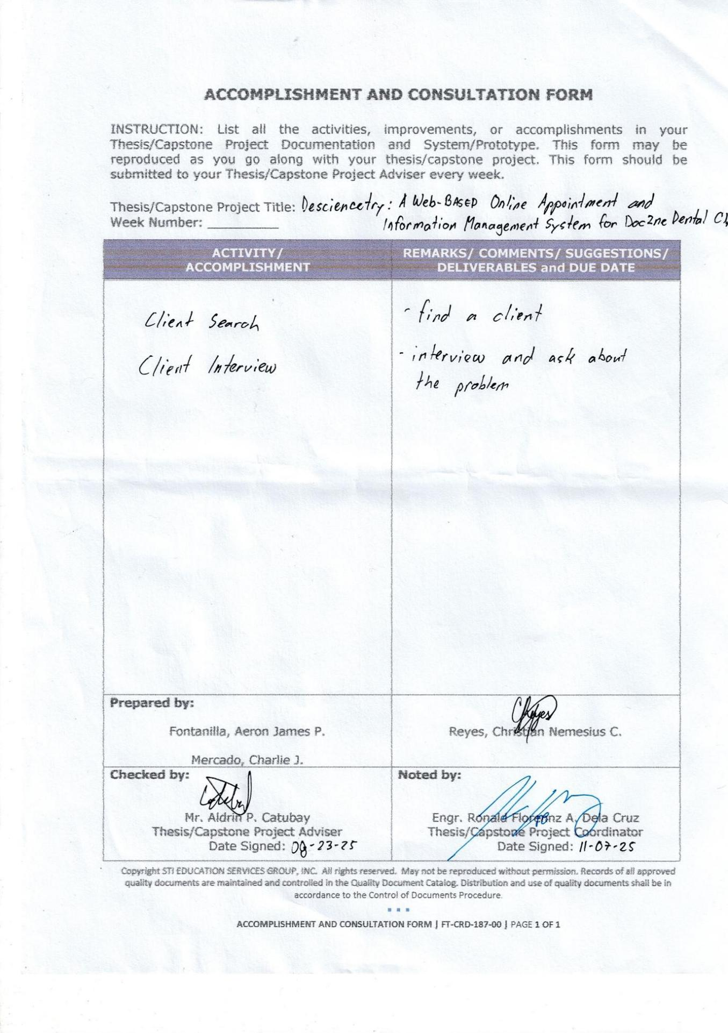

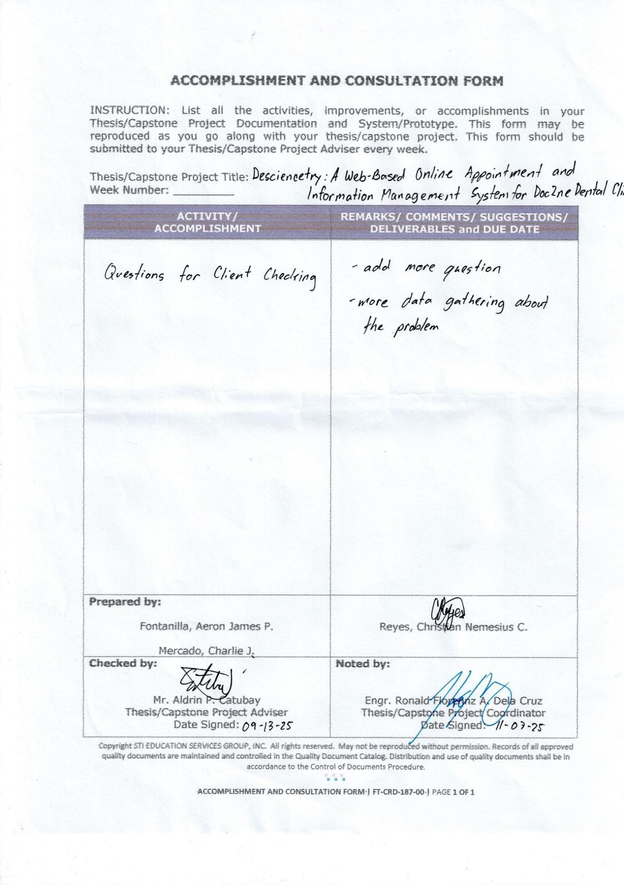

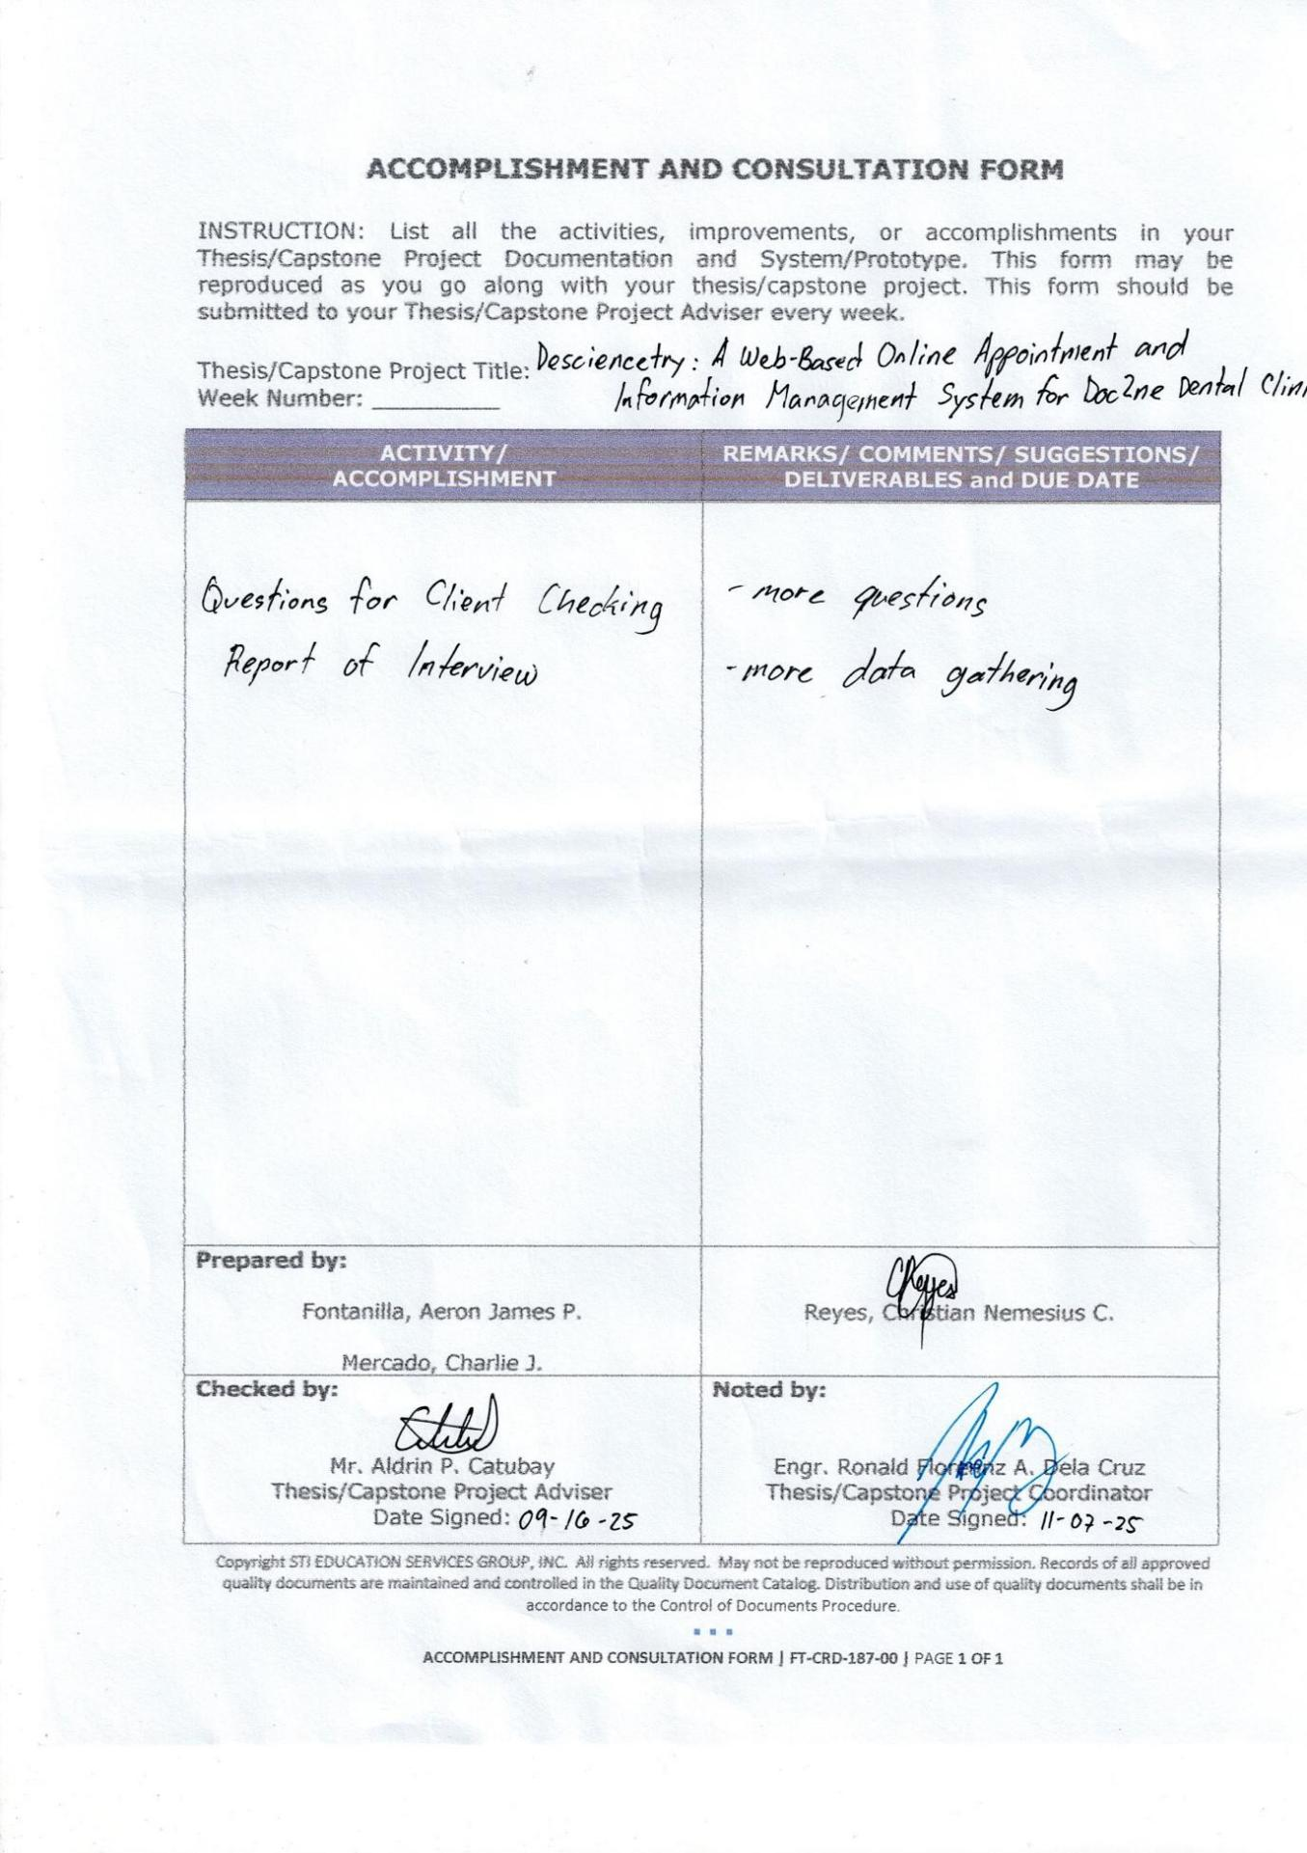

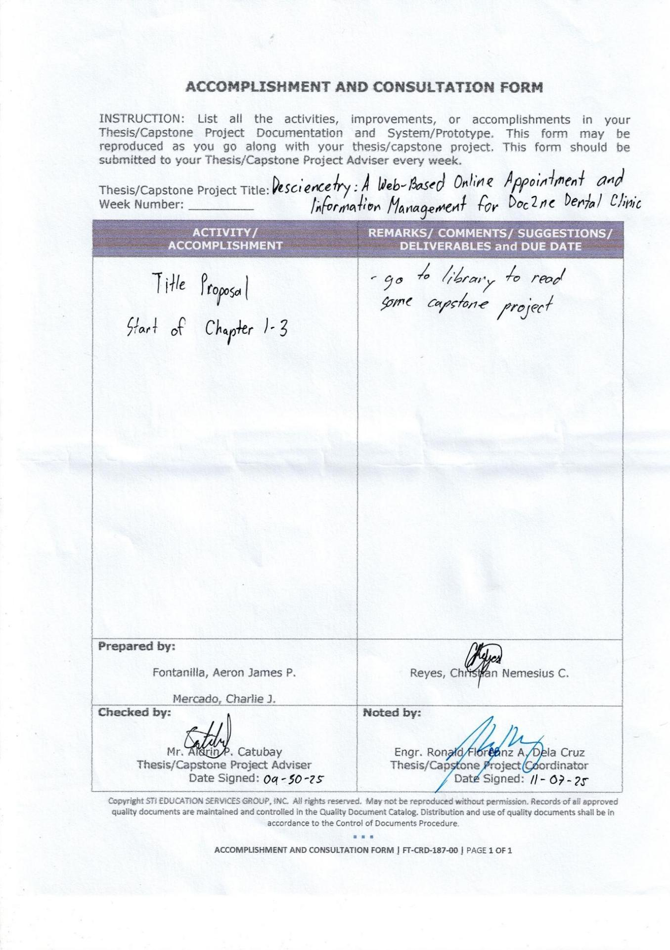

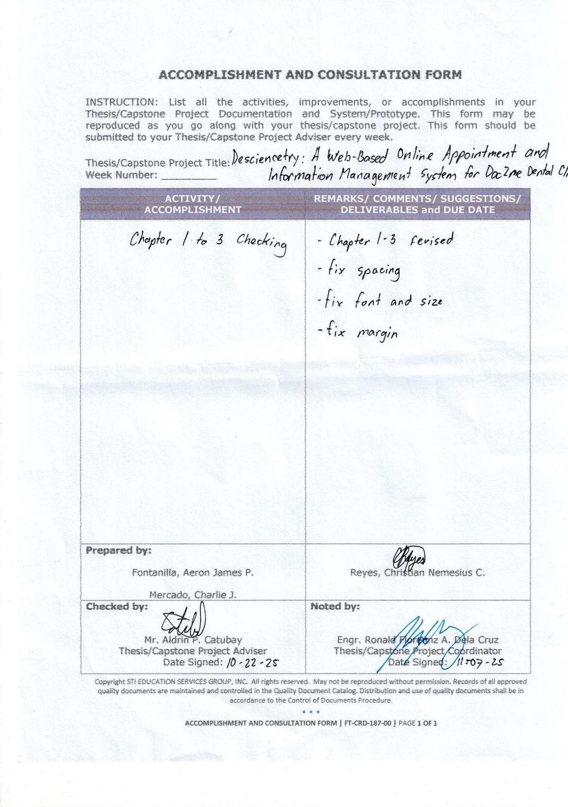

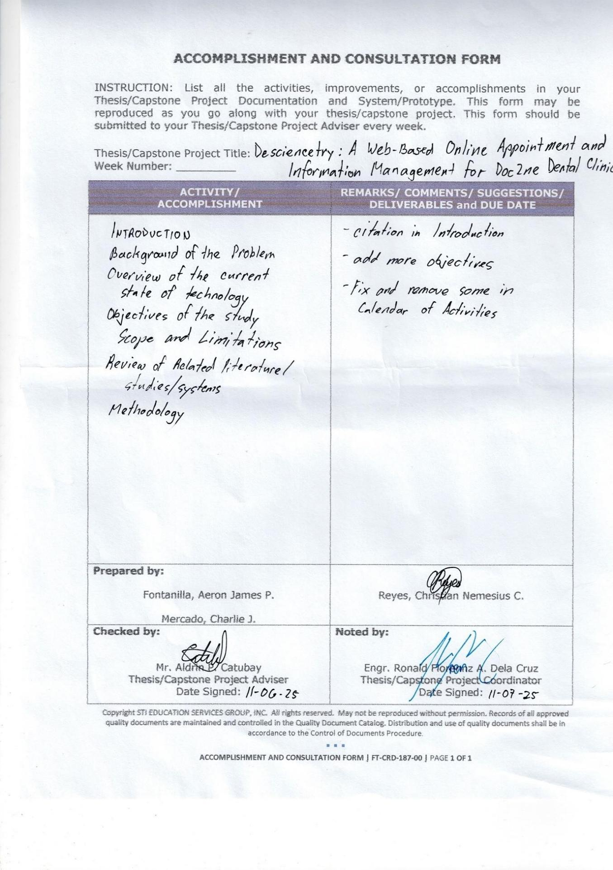

APPENDIX C
ENTITY RELATIONSHIP DIAGRAM

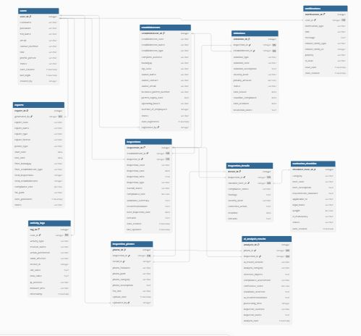

Figure 27. Entity relationship diagram.

